The lightning flash with arrowhead symbol, within an equilateral triangle, is intended to alert the user to the presence of un-insulated “dangerous voltage” within the product’s enclosure that may be of sufficient magnitude to constitute a risk of electric to persons.
The exclamation point within an equilateral triangle is intended to alert the user to the presence of important operating and maintenance (servicing) instructions in the literature accompanying the appliance.
CAUTIONS:
- To reduce the risk of electric shock, do not remove the cover (or back). No user-serviceable parts inside. Refer servicing to qualified service personnel. Unplug the product from the wall outlet before servicing or when it is not used for a long period of time.
- The manufacturer should not hold responsibility for the damage caused by any substitutions and modifications of the product without authorization from the manufacturer or authorized organization.
- Do NOT use any other charging device other than the one including in the package to charge the device. Failure to comply may result in device damage.
- Do NOT leave the device connected to the charger longer than expected charging time period as excessive charging may reduce battery life.

Table of Contents
1. Getting Started 2
1.1 Safety Precautions 3
1.2 Package Content 3
1.3 Product Views 4
2. Device Charging 4
3. Device Pairing 5
4. General Operations 5
5. Device Reset 6
6. Troubleshooting 6
7. Appendix 7
7.1 Product Specifications 8
7.2 Technical Support and Warranty Information 8
7.3 Disclaimer 8

- Getting Started

Thank you for purchasing Prestigio Bluetooth Car Kit. You have made an excellent choice and we hope you will enjoy all of its capabilities. Please read through the user manual carefully before using the product, and follow all of the procedures in the manual to fully enjoy all features of the product.

  - Safety Precautions

Please observe all safety precautions before using Prestigio Bluetooth Car Kit. Please follow all procedures outlined in this manual to correctly operate the device. Failure to comply with the following potentially hazardous situations may result in injury or property damage.

- Do NOT attempt to disassemble or alter any part of the device that is not described in this guide.
- Do NOT block any ventilation openings.
- Do NOT place the device in contact with water or any other liquids. The device is NOT designed to be liquid proof of any sort.
- In the event of liquid entry into interior of device, immediately disconnect the device from the computer. Continuing use of the device may result in fire or electrical shock. Please consult your product distributor or the closest support center.
- To avoid risk of electrical shock, do not connect or disconnect the device with wet hands.
Do NOT place the device near a heat source or directly expose it to flame.
- Do NOT place the device in vicinity of equipments generating strong electromagnetic fields. Exposure to strong magnetic fields may cause malfunctions or data corruption and loss.

  - Package Content

Item | Description | Quantity
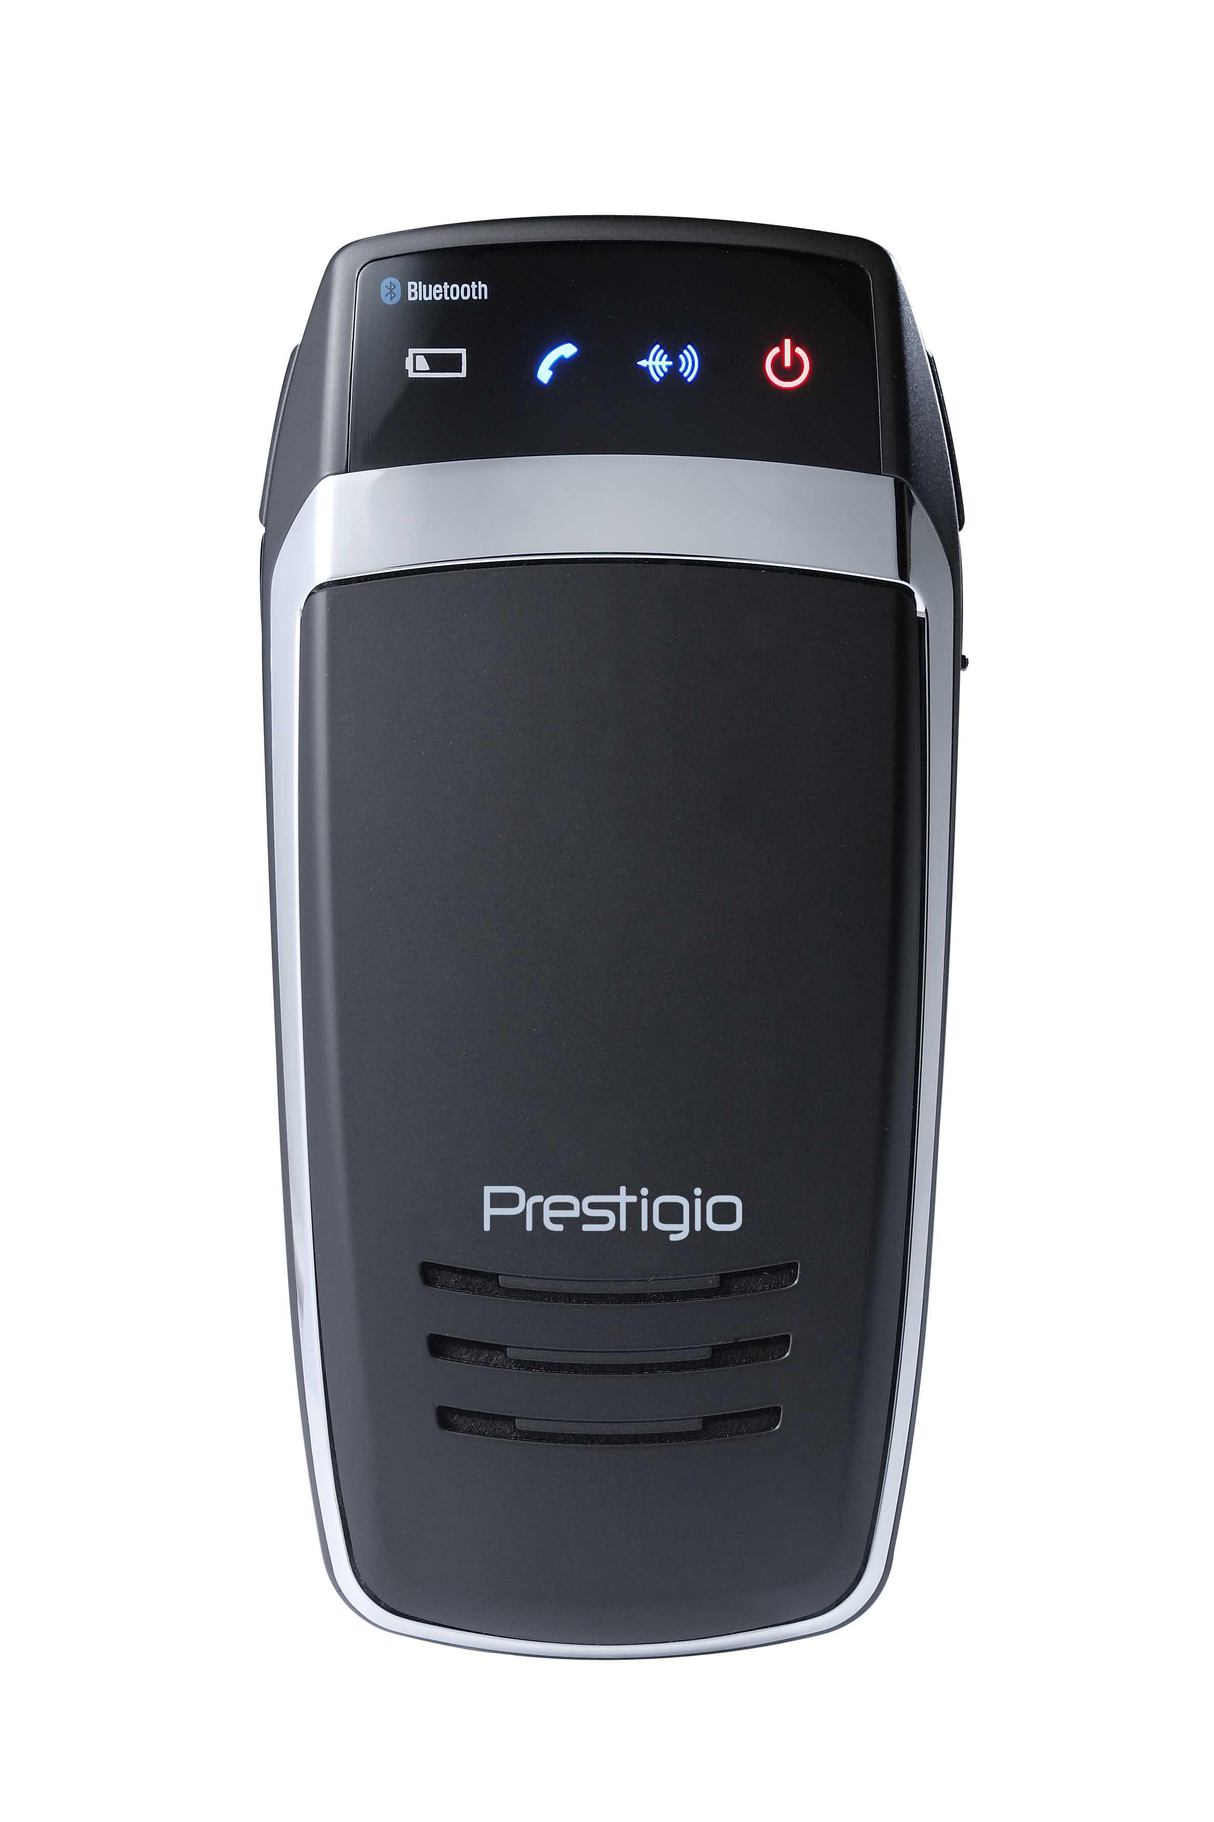 | Prestigio Bluetooth Car Kit | 1
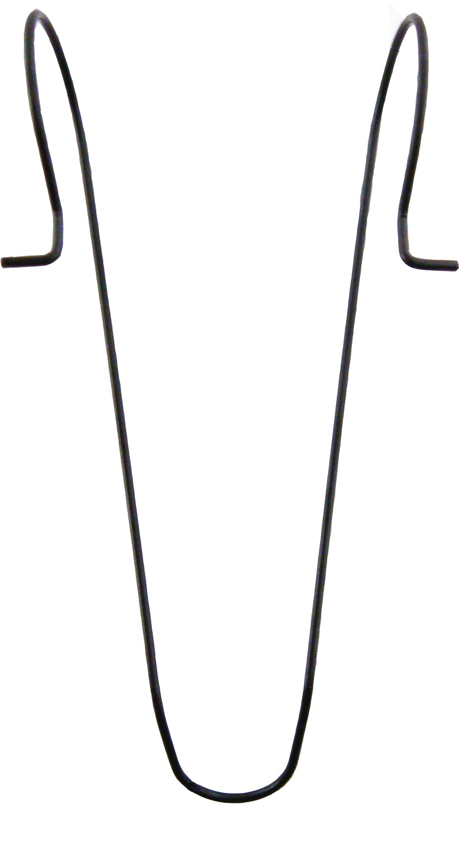 | Visor Clip | 1
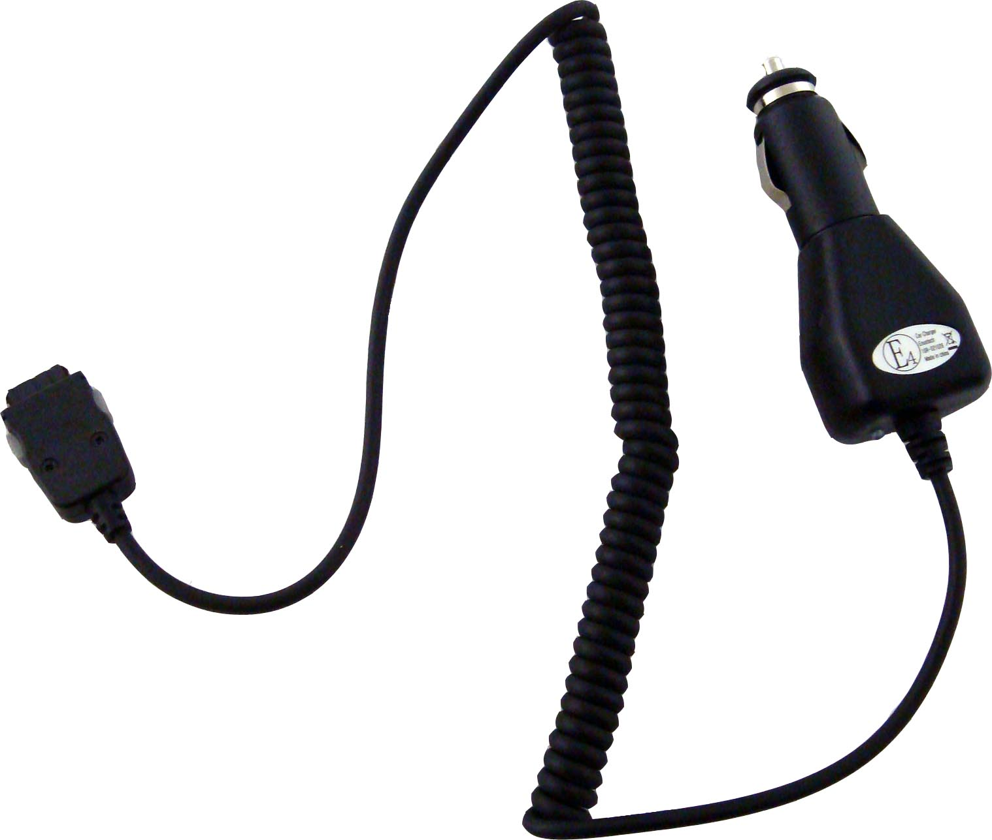 | Car Charger | 1
 | User Manual | 1
 | Documentation CD | 1

  - Product Views

The images in this document are for user reference only. The actual product may look slighly different from these images.
1
5
2
3
4
6
6
8
7
9

- Power LED
Lights up in red when power is on.
- Bluetooth LED
Standby Mode: Flashes 2 times every 2 second.
Pairing Mode: Flashes continuously.
Active Mode: Stays on.
- Status LED
Lights up when active.
- Low Battery LED
Lights up when battery is low.
- Microphone
Receives voice from user
- Volume Control Buttons
Adjusts volume:
Left button – increases volume.
Right button – lowers volume.
- Multi-Function Button
Turns on the unit
Initiate pairing
Enters/exits standby mode.
- Charging Socket
Connects to car adapters for charging
- Speaker
Sends out analog/digital voice.

- Device Charging

WARNING:
It is recommended to fully charge Prestigio Bluetooth Car Kit before first time operation. Failure to comply may shorten battery life.

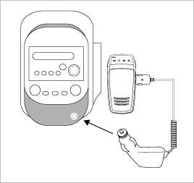 | - Insert the car charging tip into the charging socket equipped in vehicle.  - Insert the other end into Prestigio Bluetooth Car Kit.  - The indicator on the charger will be illuminated with red light while charging and changed to green light when charging is completed.  - It takes approximately 2 hours to fully charge the device.

WARNING:
Immediately turn off the unit and disconnect the power adapter if the unit is not working properly. Never try to repair the unit without authorized professionals for it may damage the unit.

- Device Pairing
- Press and hold Volume Down button for 5 seconds to enter pairing mode.
- Release the button when the Bluetooth LED starts to flash repeatedly with beeping sound.
NOTE:
The device will automatically enter standby mode when pairing process exceeds 2 minutes. Restart the process if necessary.
- Connect Prestigio Bluetooth Car Kit to desired mobile phone. Refer to mobile phone manual for further instructions.
- When pass key is prompted, please enter 0000 on the mobile phone to ensure encrypted connection.

- General Operations

- Turning power ON/OFF
- Press and hold the Multi-Function Button for 2 seconds to turn on the device.
- Press and hold the button again for 5 seconds to turn off the device.
- Reconnecting device to mobile phone
Short-press Multi-Function Button to reestablish connection when it is interrupted.
- Disconnecting the device from mobile phone
Press and hold both Volume Control Buttons simultaneously for 1 second to disconnect the device from mobile phone. The function is only available when there is no activity between devices.
- Receiving calls/Ending calls/Voice Dial
- Short-press the Multi-Function Button to answer a call.
- Press and hold the Multi-Function Button for 2 seconds to end a call.
- Short-press the Multi-Function Button to start voice dialing when the device is in idle mode.
- Transferring calls
- Short-press the Multi-Function Button 2 times to transfer an existing phone call from mobile phone to Prestigio Car Kit.
- Short-press the button again 2 times to transfer the existing phone cal back to mobile phone.
- Rejecting calls
Press and hold the Multi-Function Button to reject an incoming call without answering it.
- Redialing from last phone number
Press the Multi-Function Button 2 times to redial the last dialed/received phone number.
- Turning volume up/down
Press the Volume Control Buttons to adjust ring volume/speaker volume during idle mode/talk mode accordingly.
- Mute/Resume
Press both Volume Control Buttons simultaneously to mute. Press the buttons again to resume.
- Auto power off
The device is automatically turned off after entering idle mode for more than 1 hour.
- Auto reconnecting
Prestigio Car Kit automatically reestablishes connection with last synchronized mobile phone in range while the device is turned on.

- Device Reset

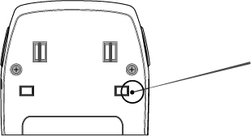 | To restore Prestigio Car Kit back to factory setting, simply press the RESET button located as shown in the diagram.  NOTE:  All previous synchronization record will be permanently deleted upon resetting.

- Troubleshooting

Please refer to the following procedures if Prestigio Car Kit does not function as it should be. Be advised that the following instructions are only intended for simply troubleshooting purpose. Please contact your local authorized shops for further troubleshooting and technical support.

Problem | Solution/Suggestions
Prestigio Car Kit can not be turned on. | The battery in the device might be flat. Please charge the device before turning power on.
Pairing failed/Unable to perform pairing process. | - Shorten the distance between devices by bringing both devices closer to each other.  - Please make sure the host mobile phone is in bluetooth pairing mode.  - Please move both devices away from electrical devices generating strong microwave/electromagnetic fields such as microwave oven, walkie-talkie, etc.
Phone calls are not received by Prestigio Car Kit. | Please ensure that the host mobile phone is powered on and its bluetooth function is enabled.
Buttons on Prestigio Car Kit stops to function properly. | - Please ensure that the device is charged before using.  - Reset the device to its factory setting.

- Appendix

  - Product Specifications

Bluetooth Compliance | Bluetooth 2.0
Transmission Power | Class 2 (+4dBm Maximum)
Receiver Sensitivity | -82dBm
Operation Range | Up to 10 meter (33 feet)
Security | 128bit encryption
Supporting Profile | Headset profile, Hands-free profile
Battery Type | Lithium Polymer battery cell
Battery Capacity | 1100mAh
Charging Time | 2.5 hours
Standby Time | 15 days
Operation Time | 12 hours
Dimensions | 60mm X 124mm X 13mm (L*W*D)
Weight | Approximately 100g

  - Technical Support and Warranty Information

Please refer to www.prestigio.com for technical support and warranty information.

  - Disclaimer

We made every effort to ensure that the information and procedures in this user manual are accurate and complete. No liability can and will be accepted for any erros or omissions. Prestigio reserves the right to make any changes without further notice to any products herein.

