Instruction

1. Place the notebook on the notebook cooling stand
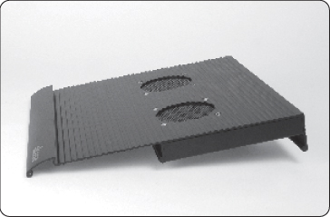 |  | 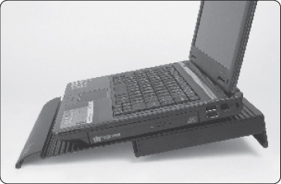

2. Connect one end of the provided USB cables to any available USB port on the notebook and the other end to one of the notebook cooling stand USB ports. Switch on the notebook cooling stand and start the system.
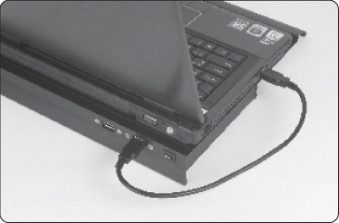 |  | 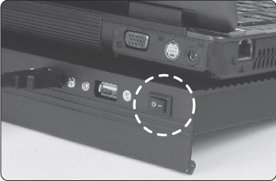

NOTE: The notebook cooling stand fans blow cool air directly up to the Notebook base, do not cover the cooler fans vent with anything apart from the Notebook PC.
The second USB port on the notebook cooler can be used for low power devices (up to 1.5 W).

