1. Packing List
1. Prestigio car DVR | 2. Suction mount
3. DC 5V car charger | 4. USB Cable
5. Quick start guide | 6. AV cable
2. Device Overview
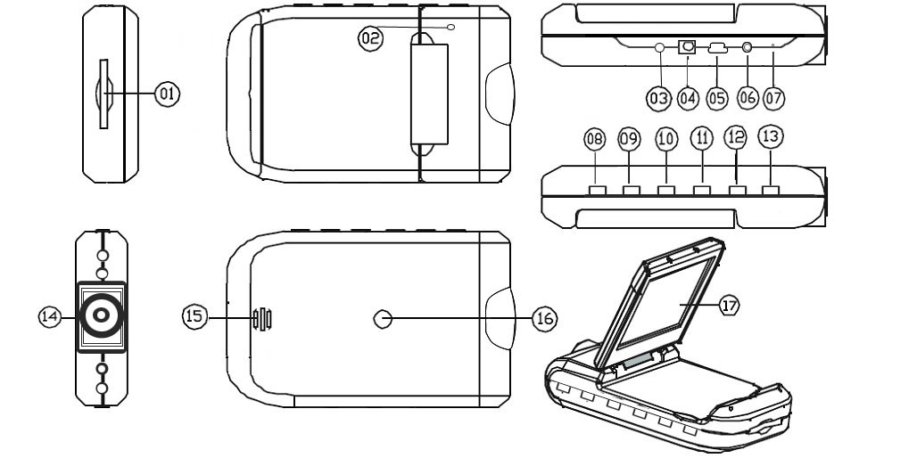
1 | SD/MMC Card Slot | 10 | UP
2 | Microphone | 11 | REC / Snap
3 | LED indicator (glows with green when working and with red when charging) | 12 | Menu
4 | 5V DC Slot | 13 | ON/OFF Power Switch
5 | Mini USB port | 14 | Lens
6 | AV out | 15 | Speaker
7 | Reset | 16 | Mount hole
8 | Mode Button | 17 | 2.5 inch LCD
9 | Down

Getting started
3. Power on/Power off
- Position the device in the vehicle and press the Power Switch
to turn it on. Turn the device off by pressing
again.
- You can also connect the device to the car charger. It will automatically turn on and start recording when the car engine starts. When the engine stops, the device will automatically save the last file and turn off.
4. Charging
- Connect the device to the USB port or car charger. The LED indicator will glow with red when charging, turn off, when the device is fully charged and glow with green when recording.
- Normally it takes approximately 3 hours to fully charge the device. Operating the device while charging with the AC adapter may extend the time of full charge.
Note:
Before using the device for the first time, please, connect it to the PC or notebook using the USB cable provided to fully charge the Li-ion battery. The battery is completely charged in 3-4 hours.
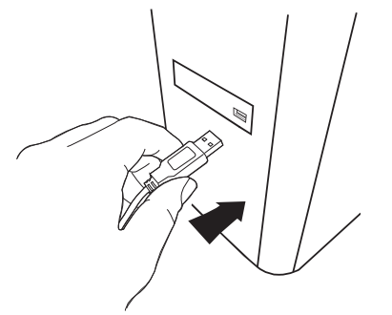
Note:
The device can also be charged via car charger. Connect the device to the car cigarette lighter when the car engine is working.
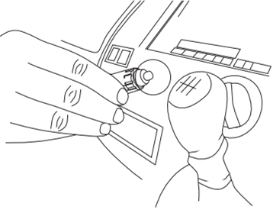
5. Inserting the SD-card
- Before starting video recording, please, insert an SD or SDHC card into the SD card slot in the device.
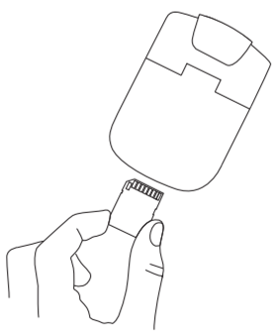
6. Recording
- The device will automatically start recording when turned on, and the LED indicator will start flashing. The recorded files are saved on
SD/MMC Card. To stop recording, press the button or
stop the car engine if the device is connected to the car charger. The indicator will stop blinking.

Home screen
7. Main menu
During video registration the following symbols are displayed on the home screen:
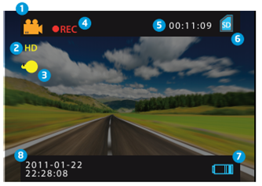
1 | Selected mode
2 | Image size
3 | LED indicator (on/off)
4 | REC - Displayed when recording is being performed
5 | Selected file duration (when recording)  The amount of video files, which can be saved on the SD card (when not recording)
6 | Appears when an SD card is inserted
7 | Battery level
8 | Current time and date

Settings

8. Video Mode Settings
- Turn on the device and press button to enter Settings. Press / to select the settings options and enter the sub-menu by , select the options by pressing / , confirm by pressing , afterwards the settings
are saved and the device exits the options menu.
The following options list is available:
- Image Size: Select the image size from HD 1280x720 or VGA 640x480
- Time stamp: Select to turn time stamp on the images on or off.
- Motion detect: After selecting this option the device will automatically start recording upon detecting any motion.
Note: After enabling this function the device will start recording automatically if it detects a moving object. The file duration will be set according to the Recording time settings. For example, if the recording time is set for 2 min, video recording will last for 2 minutes, and if there is no movement detected, the device will stop recording, or continue recording a new file if a movement is still being detected.
- Audio record: Select to turn on audio recording.
- Recording time: Select the file duration (2 Minutes / 5 Minutes/ 15 Minutes).
- Led Mode: Select to choose auto mode or to cancel it.

9. Other Settings
Press to enter “Setup”. Press / to navigate in
the options list. The following settings are available:
- Format: Select OK to format the SD card.
- Language: Select the desired language from the list.
- Default Settings: Select OK to restore the default settings.
- Frequency: Select the frequency between 50HZ /60HZ.
- Date: Set the correct date.

10. DSC Mode Settings
To enter digital camera settings press button once. To take a picture press . To enter menu options press button. Press / to navigate between the options and press to enter sub-menu. To select options press / , press to confirm selection. Afterwards the
settings are saved and the device exits the options menu.
The following settings are available:
- Image Size: Select the image size between 5M 2560 x 1920, 3M 2048 x 1536, 2M1600 x 1200, 1M 1280 x 1024.
- Time stamp: Select to turn time stamp on the images on or off.
- Led Mode: Select to choose auto mode or to cancel it.

11. Playback Mode Settings
To enter playback mode settings press button twice, then press / to select the recorded file from SD/MMC card and press to playback. To enter menu options press
button. The following settings are available:
- Delete: Select to delete one file, all or cancel.
- Show thumbnails: Select to display or hide thumbnails.
- Volume adjust: Select to adjust the volume
12. USB connection
To download registered files on your PC/notebook, please, connect the device to the PC or notebook via USB-cable provided. In “My computer” select the removable disk. All registered files are stored in DCIM folder, under the name PICT**** in AVI format. You can now download the files from the device.

13. Playback on TV
To playback the recorded files on TV-set connect the device to your TV with the AV cable provided and then turn on the device. It will automatically enter the Playback mode. The options are similar to those of the section 11 (Playback mode).

Notes:
- Please insert the SD/ MMC card before recording.
- When the SD/MMC card is out of memory, it will automatically erase the old files and start recording from the beginning. Before rewriting the old files the device will pause recording for 3 seconds.

Safety precautions

Please observe all safety precautions before using Prestigio Roadrunner HD1. Please follow all procedures outlined in this manual to correctly operate the device.
- Do not attempt to disassemble or alter any part of the device that is not described in this guide.
- Do not place the device in contact with water or any other liquids. The device is NOT designed to be liquid proof of any sort.
- In the event of liquid entry into interior of device, immediately disconnect the device from the computer. Continuing use of the device may result in fire or electrical shock. Please consult your product distributor or the closest support center.
- To avoid risk of electrical shock, do not connect or disconnect the device with wet hands.
- Do not place the device near a heat source or directly expose it to flame or heat.
- Never place the device in vicinity of equipments generating strong electromagnetic fields. Exposure to strong magnetic fields may cause malfunctions or data corruption and loss.

Technical Specifications

Recording resolution | 1280*720/ 640*480 pixels
Video format | Avi
Recording time | 2/5/15 minutes
Power source | Built-in rechargeable battery
Interfaces | AV out, USB, SD/MMC card (Support max 32GB, high-speed SD/MMC card recommended)
Microphone | Built-in
Operating temperature | - 35°~ 70°C

Disclaimer

As the Prestigio products are constantly updated and improved, your device may have a slightly different appearance or modified functionality than presented in this Quick Start Guide.

