Table of Contents
1 Getting Started
1.1 Safety Precautions
1.2 Copyright Protection
1.3 Package Content
2 Main Unit Views
2.1 Front View
2.2 Right Side View
2.3 Left Side View
2.4 Bottom View
3 2nd Moniter Views
3.1 Front View
3.2 Right Side View
3.3 Buttom View
4 Remote Control Overview
4.1 Button Definition
4.2 Remote Control Battery Installation
5 System Connections
5.1 Connecting to TV
5.2 Connecting to Amplifier
5.3 Connecting to Headphones
5.4 Connecting to AC Adapter
5.5 Connecting to Car Adapter
5.6 Connecting to Main Unit

6 Battery Pack Operations
6.1 Attaching/Detaching Battery Pack
6.2 Charging Battery Pack
7 Software Compatibility
7.1 Compatible Disc Format
7.2 Disc Maintenance
8 General Operation
8.1 Before Playing
8.2 Adjusting Screen Aspect Ratio
9 DVD Disc Playback Operations
10 CD Disc Playback Operations
11 JPEG File Viewing Operations
12 System Setup
13 Using Straps
14 Troubleshooting
15 Appendix
15.1 Product Specification
15.2 Technical Support and Warranty Information
15.3 Disclaimer

The lightning flash with arrowhead symbol, within an equilateral triangle, is intended to alert the user to the presence of un-insulated “dangerous voltage” within the product’s enclosure that may be of sufficient magnitude to constitute a risk of electric to persons.
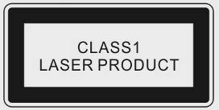
The exclamation point within an equilateral triangle is intended to alert the user to the presence of important operating and maintenance (servicing) instructions in the literature accompanying the appliance.
WARNING:
The device emits laser radiation when opened. Do NOT stare into laser beam directly.
CAUTION:
- The product is equipped with a low power laser device. To ensure the quality of the laser device, do NOT open up the case or attempt to repair the unit. Please contact authorized service center for any service required.
- To reduce the risk of electric shock, do NOT remove the cover. No user-serviceable parts inside. Refer servicing to qualified service personnel. Unplug the product from the wall outlet before servicing or when it is not used for a long period of time.
- The manufacturer should not hold responsibility for the damage caused by any substitutions and modifications of the product without authorization from the manufacturer or authorized organization.

- Getting Started

Thank you for purchasing Prestigio PPDP 370 Twin, a mobile digital media center. You have made an excellent choice and we hope you will enjoy all of its exciting features. Please read through the user manual carefully before using the product, and follow all of the procedures in the manual to fully enjoy all features of the product.

  - Safety Precautions

Please observe all safety precautions before using Prestigio PPDP 370 Twin. Please follow all procedures outlined in this manual to correctly operate the device.

Warning: This mark indicates actions that could lead to serious injury to personnel operating the device or damage to the device if ignored or handled incorrectly.

- Do not attempt to disassemble or alter any part of the device that is not described in this guide.
- Do not place the device in contact with water or any other liquids. The device is NOT designed to be liquid proof of any sort.
- In the event of liquid entry into interior of device, immediately disconnect the device from the computer. Continuing use of the device may result in fire or electrical shock. Please consult your product distributor or the closest support center.
- To avoid risk of electrical shock, do not connect or disconnect the device with wet hands.
- Do not place the device near a heat source or directly expose it to flame or heat.
- Never place the device in vicinity of equipments generating strong electromagnetic fields. Exposure to strong magnetic fields may cause malfunctions or data corruption and loss.

  - Copyright Protection

This product incorporates copyright protection technology that is protected by U.S. patents and other intellectual property rights. Use of this copyright protection technology must be authorized by Macrovision, and is intended for home and other limited viewing uses only unless otherwise authorized by Macrovision. Reverse engineering or disassembly is prohibited.

DVD players and discs are coded by region. If the region number described on the DVD disc does not correspond to the region number of this product, the DVD disc can not be played by the unit. Prestigio PPDP 370 Twin is coded with region number 2 and is intended for European standard DVD disc use only.

  - Package Content
Item | Description | Quantity
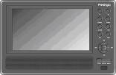 | Prestigio PPDP 370 Twin DVD Player | 1
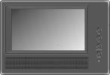 | 2nd Monitor | 1
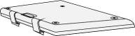 | Battery Pack | 1
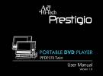 | User Manual | 1
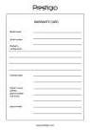 | Warranty Card | 1
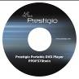 | Documentation CD | 1
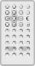 | Remote control  (battery included) | 1
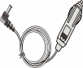 | Car Adapter | 1
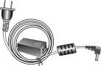 | Power Supply Cable with AC Adapter | 1
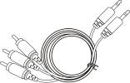 | Audio/Video Cable | 2
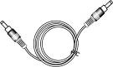 | Power Supply Cable | 1
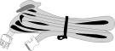 | Straps | 4
- Main Unit Views

  - Front View

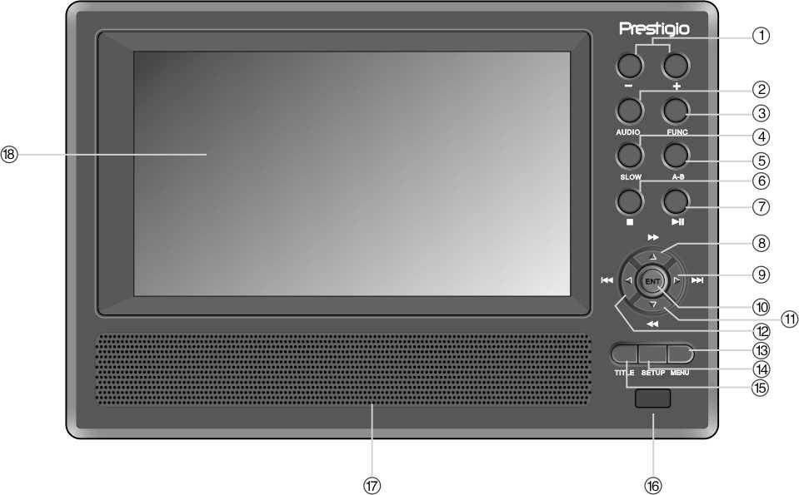

Number | Button Name | Function
1 | -/+ Button | Press to adjust the screen brightness and color.
2 | AUDIO Button | Press to cycle through different language when playing a DVD disc (multiple languages subtitle required).
3 | FUNC Button | Press to change the brightness and color level. Press and hold for 1-2 seconds to change the aspect ratio between 16:9 and 4:3.
4 | SLOW Button | Press to activate the slow playback function.
5 | A-B repeat Button | Press to play a certain selected segment repeatedly.
6 | (Stop) Button | Press to stop playback. Then press the button to resume playback from the stopped spot. Press twice to stop playback completely.
7 | (PLAY/PAUSE) Button | Press once to pause the playback and press it again to resume playback.
8 | ▲/ Button | Press to scroll up or to fast forward during playback.
9 | ►/ Button | Press to scroll right or to skip to the next list, track or chapter.
10 | ENT Button | Press to start playback or to confirm selection.
11 | ▼/ Button | Press to scroll down or to rewind during playback.
12 | ◄/ Button | Press to scroll left or to return to the previous list, track or chapter.
13 | MENU Button | Press to enter menu or to exit from the menu.
14 | SETUP Button | Press to enter or to exit from system setup.
15 | TITLE Button | Press to enter the title menu if available.
16 | Remote Control Sensor
17 | Speaker
18 | LCD Screen

  - Right Side View

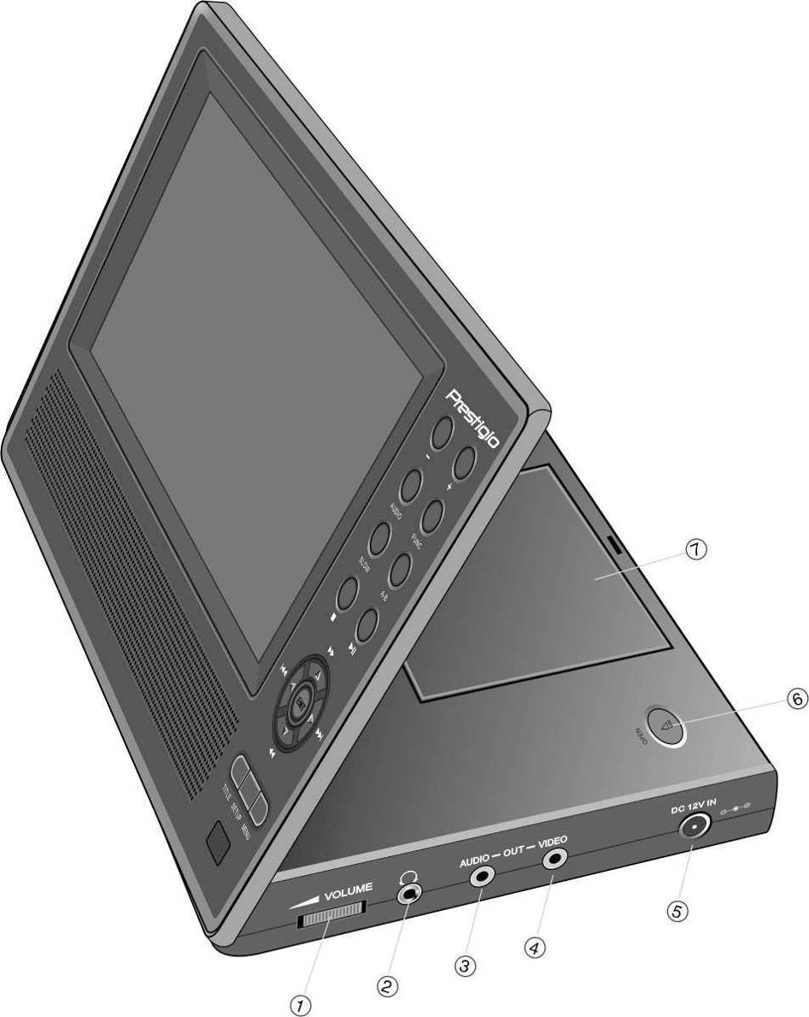

Number | Button Name | Function
1 | VOLUME Control | Scroll left and right to adjust volume of the headphone or speaker.
2 | Headphone Jack | Connects to headphone sets. Speakers automatically mute when headphone sets inserted.
3 | AUDIO OUTPUT Jack | Connects to external amplifier.
4 | VIDEO OUTPUT Jack | Connects to external monitor.
5 | DC 12V INPUT Jack | Connects to AC and car adapter.
6 | OPEN Switch | Press to open disc tray cover.
7 | Disc Tray Cover | Press to close cover after disc is loaded.
  - Left Side View

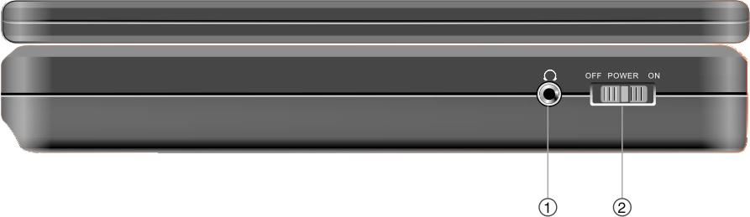

Number | Button Name | Function
1 | Headphone Jack | Connects to headphone sets. Speakers automatically mute when headphone sets inserted.
2 | Power Switch | Slide to turn power ON/OFF.

  - Bottom View
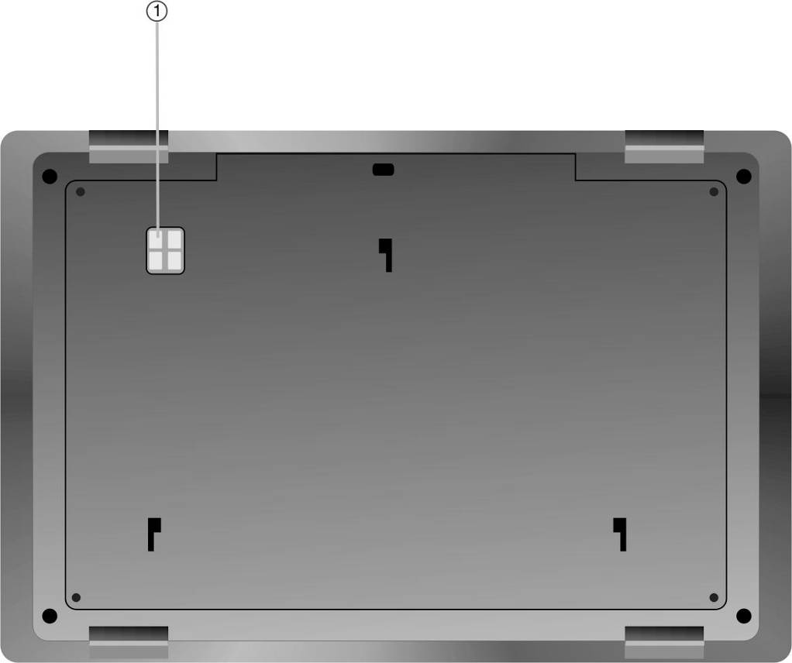

Number | Button Name | Function
1 | Rechargeable Battery Interface | Connects to rechargeable battery pack.
- 2nd Moniter Views

  - Front View
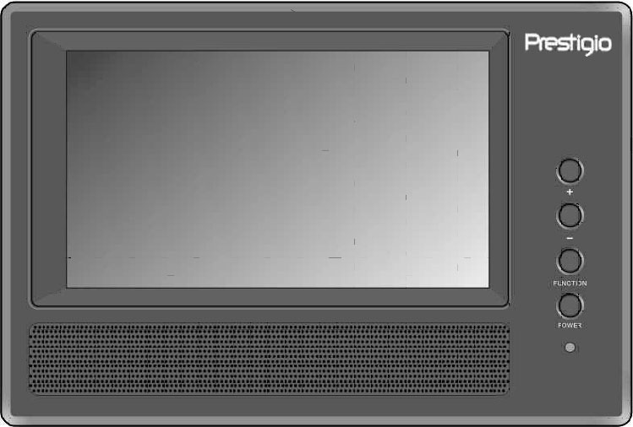
Number | Button Name | Function
1 | -/+ Button | Press to adjust the screen brightness and color.
2 | FUNC Button | Press to change the brightness and color level. Press and hold for 1-2 seconds to change the aspect ratio between 16:9 and 4:3.
3 | Power Button | Press to exit from or enter standby mode.
4 | Power Indicator | The light shines red during standby mode.
5 | Speaker
6 | LCD Screen

  - Right Side View
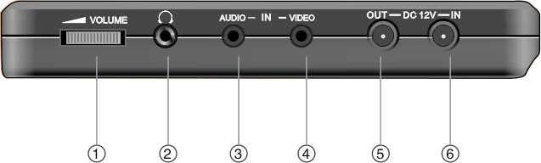
Number | Button Name | Function
1 | VOLUME Control | Scroll left and right to adjust volume of the headphone or speaker.
2 | Headphone Jack | Connects to headphone sets. Speakers automatically mute when headphone sets inserted.
3 | AUDIO INPUT Jack | Connects to main unit for audio input.
4 | VIDEO INPUT Jack | Connects to main unit for video input.
5 | DC 12V INPUT Jack | Connects to AC and car adapter.
7 | DC 12V OUTPUT Jack | Connects to main unit for power output.

  - Buttom View

Number | Button Name | Function
1 | Rechargeable Battery Interface | Connects to rechargeable battery pack.

- Remote Control Overview

  - Button Definition

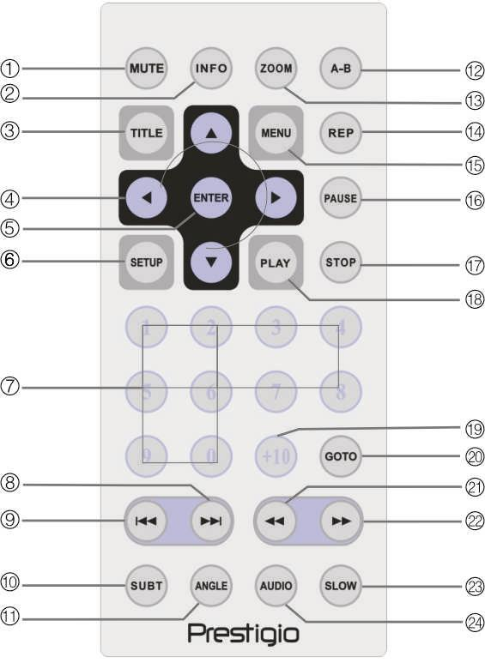

Number | Button Name | Function
1 | MUTE Button | Press to turn speaker On/Off.
2 | INFO Button | Press to display detailed file information. Press again to cancel.
3 | TITLE Button | Press to enter the title menu if available.
4 | ▲▼►◄  Directional Button | Press to navigate between different options.
5 | ENTER Button | Press to start playback or to confirm selection.
6 | SETUP Button | Press to enter or to exit system setup.
7 | 0-9 Number Button | Press to select numbers.
8 |  Next Button | Press to skip to the next list, track, or chapter.
9 |  Previous Button | Press to return to the previous list, track or chapter
10 | SUBT Button | Press to select a subtitle language (multi languages subtitle required). Press again to cancel.
11 | ANGLE Button | Press to select camera angles (camera angle adjusting function required).
12 | A-B Button | Press to play a certain selected segment repeatedly.
13 | ZOOM Button | Press to cycle through zooming functions.
14 | REP Button | Press to select different repeat and shuffle patterns.
15 | MENU Button | Press to return to or exit from the menu during playback.
16 | PAUSE Button | Press to pause playback and press PLAY button to resume playback.
17 | STOP Button | Press to stop playback. Press PLAY button to resume playback at the same point. Press STOP button twice to stop playback completely.
18 | PLAY Button | Press to start playback.
19 | +10 Button | Press to select numbers greater than 9.
20 | GOTO Button | Press to skip to a user defined title, chapter number or time.
21 |  Rewind Scan Button | Press to rewind during playback.
22 |  Forward Scan Button | Press to fast forward during playback.
23 | SLOW Button | Press to activate the slow playback function.
24 | AUDIO Button | Press to cycle through different language when playing a DVD disc (multiple languages subtitle required).

  - Remote Control Battery Installation

The remote control battery is included in the package. Please follow below steps to change battery when power runs out.

- Push and hold on the side of battery holder, then pull it out from the remote control unit as shown in the diagram. | 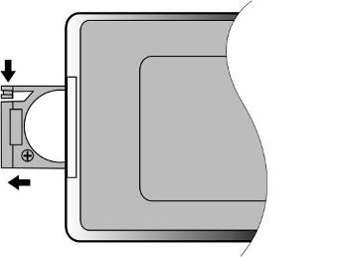
- Place a battery with type of CR2025 3V on the holder with (+) facing the back of remote control. | 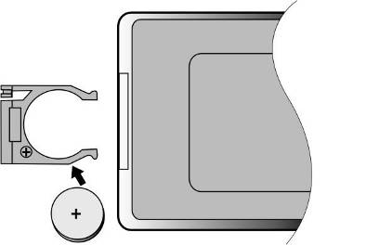
- Push the battery holder back into the remote control unit. Please make sure that the holder is firmly inserted. | 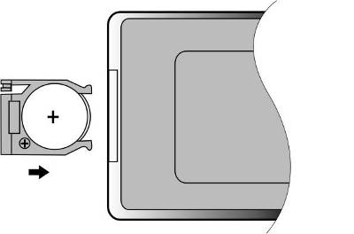
CAUTION:
- Do NOT expose the remote control unit under direct sunlight.
- Do NOT recharge, dismantle, or heat up the battery.
- Replace the exhausted battery immediately to ensure proper remote control unit functioning.

- System Connections

WARNING:
- Please switch off all devices such as TV, DVD player, etc. before connecting to the unit.
- Please match color coding on the unit and devices before connection.

  - Connecting to TV

Follow the diagram below to connect Prestigio PPDP 370 Twin with TV via Audio/Video cable.

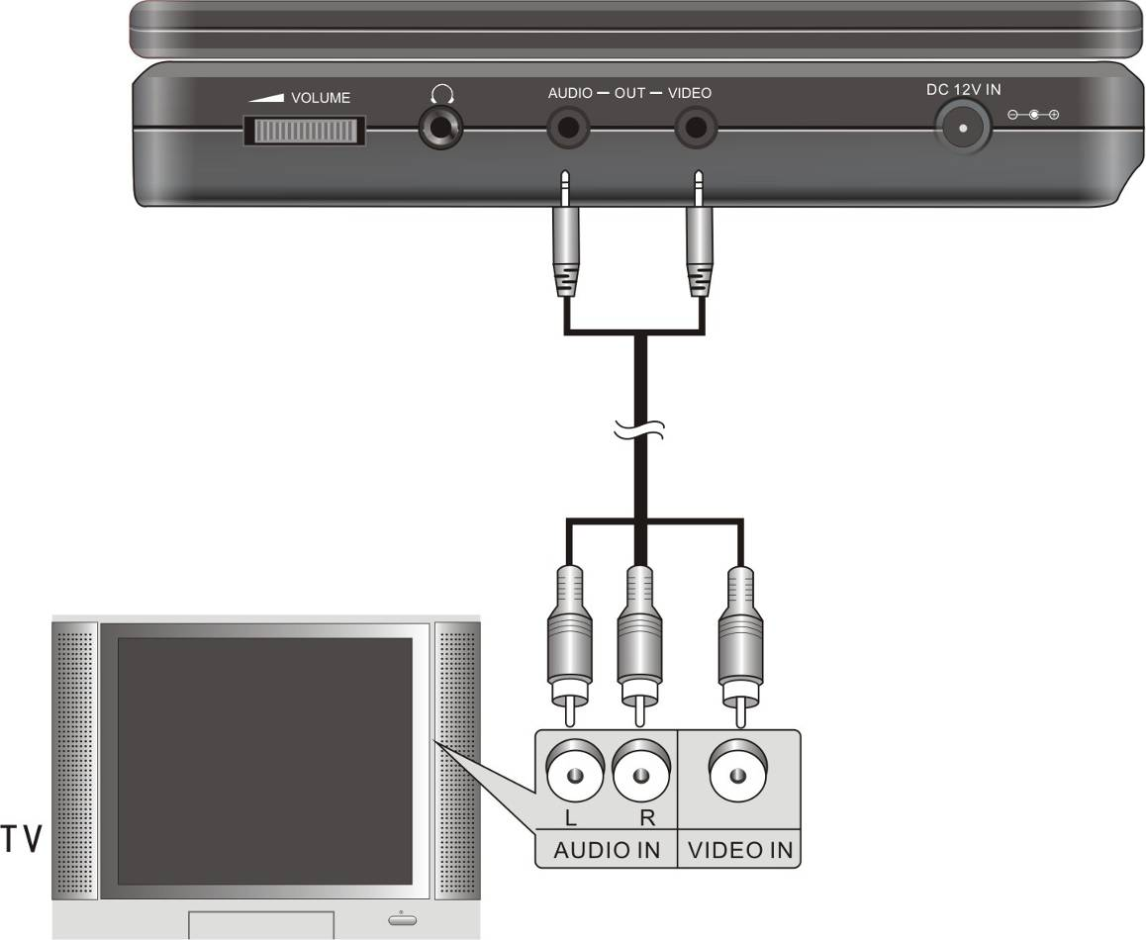

  - Connecting to Amplifier

Follow the diagram below to connect Prestigio PPDP 370 Twin with amplifier via Audio/Video cable.
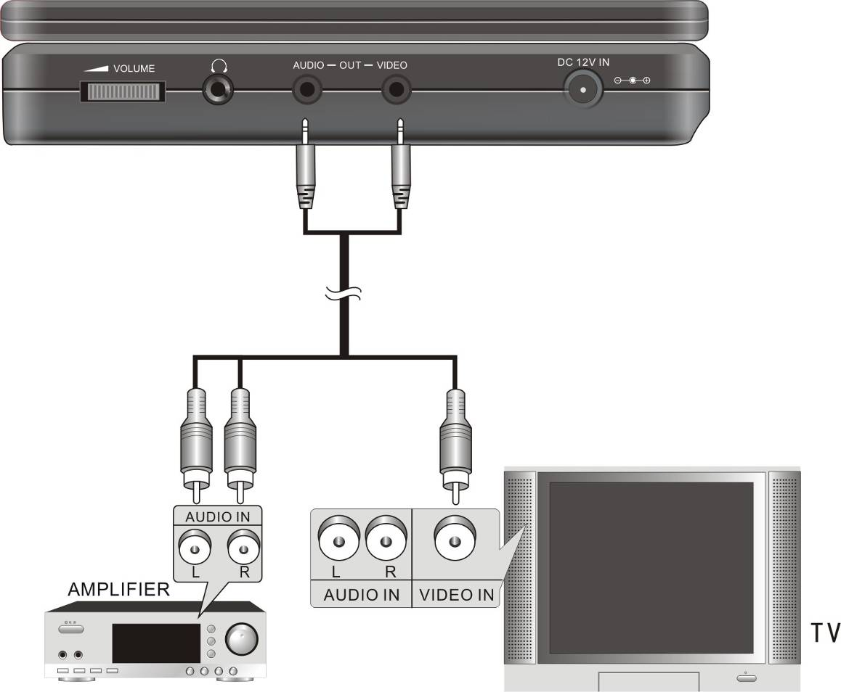

  - Connecting to Headphones

Follow the diagram below to connect Prestigio PPDP 370 Twin with headphone.
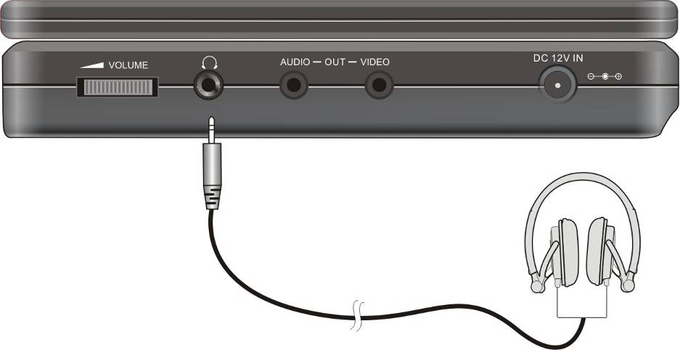

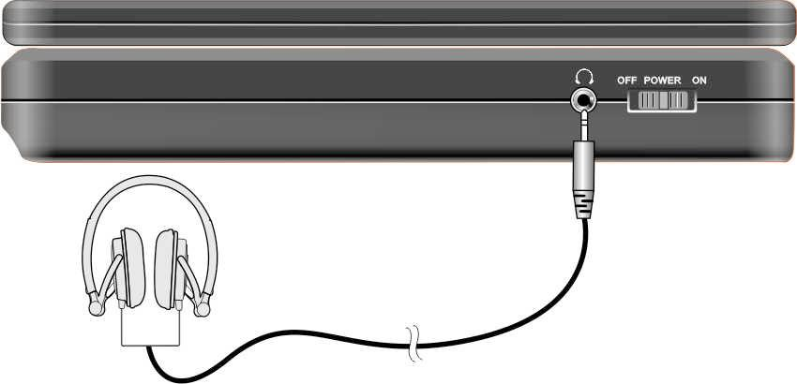
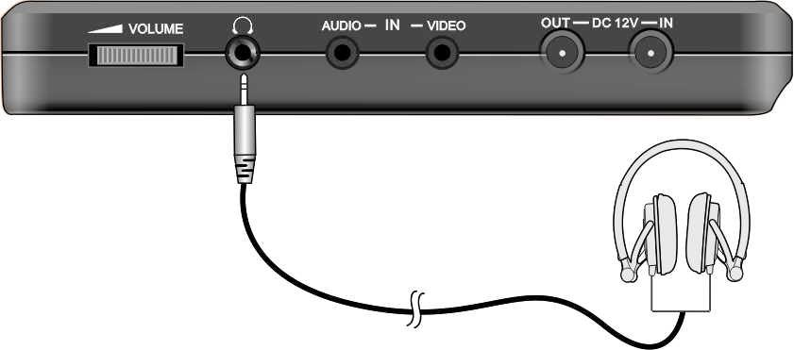
WARNING:
Excessively loud volume may detriment hearing. Turn down the volume before connecting to the earphone and then raise the volume to appropriate level.
  - Connecting to AC Adapter

Follow the diagram below to connect Prestigio PPDP 370 Twin to AC adapter for powering unit.
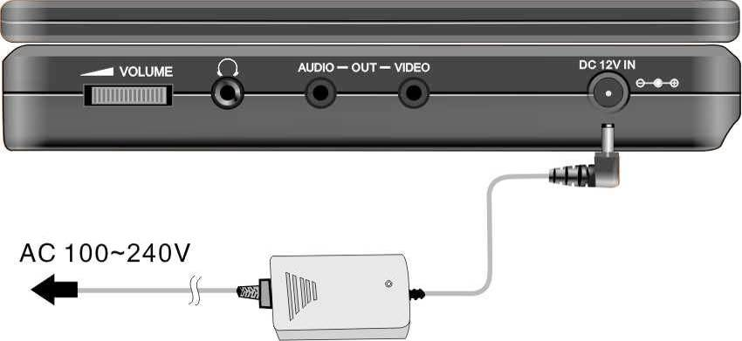

  - Connecting to Car Adapter

Follow the diagram below to connect Prestigio PPDP 370 Twin to car adapter for powering up the unit in car.
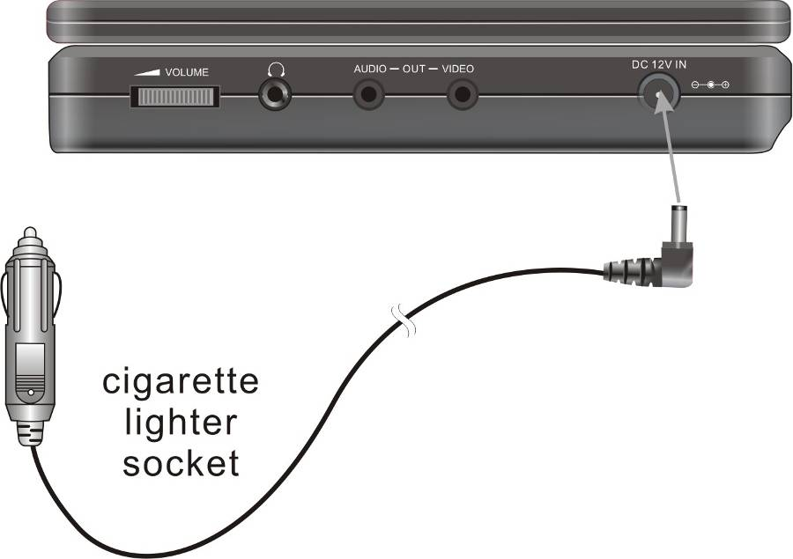
WARNING:
- Please disconnect Prestigio PPDP 370 Twin from the car adapter before starting up the vehicle.
- Do NOT operate the unit or use the device for viewing purpose while operating a vehicle.
- Please place the unit in proper viewing angle for better performance.
  - Connecting to Main Unit

Follow the diagram below to connect Prestigio PPDP 370 Twin to 2nd monitor unit. Connect the power adapter to 2nd monitor unit only and connect 2nd monitor unit to main unit using the power supply cord provided. Connect both units using the audio and video cable provided.

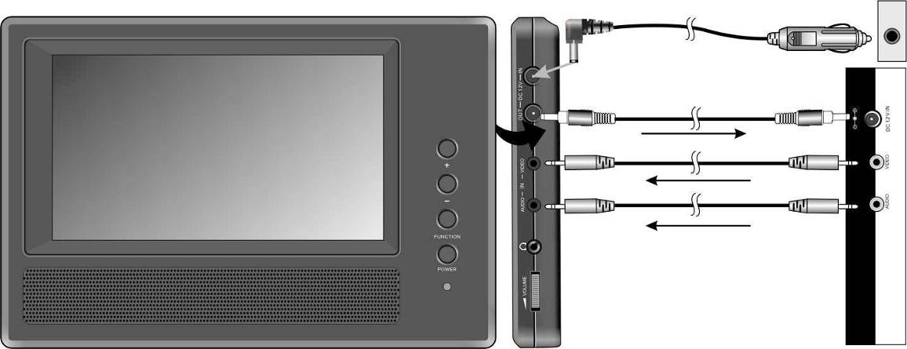

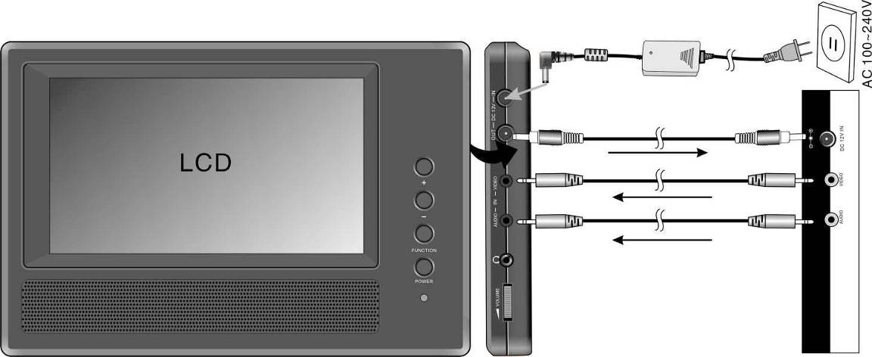

- Battery Pack Operations

  - Attaching/Detaching Battery Pack

- Hold down the main unit with one hand to prevent it from moving. Align plastic latches on the battery pack with corresponding receptacles and push it in towards the unit. | 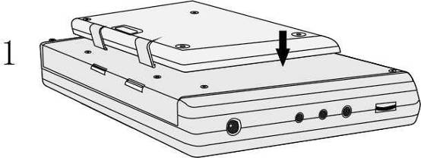
- Slide the battery pack until it clicks onto the unit. | 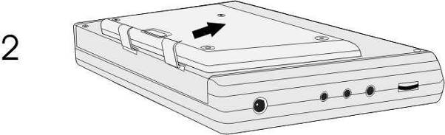
- To remove the battery pack, press and hold the release tab as shown in illustration 1.  - Gently slide the battery pack towards the top of the unit as shown in illustration 2. | 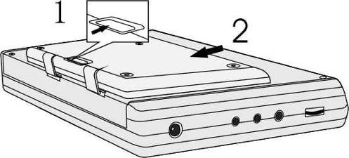

  - Charging Battery Pack

The battery pack included is made of Lithium Polymer rechargeable batteries. Please fully charge the battery pack before using for the first time. Charging time under normal conditions is approximately 5 hours. A fully charged battery pack delivers approximately 2.5 hours of main unit operation, however, operation time varies in accordance with the files being played.
WARNING:
- Please remove the battery pack if it is not being used.
- Please fully charge the battery pack before attaching it to unit.
- Battery pack should only be used and charged between temperatures of 32℉ ~ 100℉.
- Do NOT expose the battery pack to sources that radiates heat.
- Maintain well-ventilated environments around the battery pack to avoid over-heating.

- Software Compatibility

  - Compatible Disc Format

Disc Format | Disc Logo | Disc Size | Playback Time/  Playable Sides
DVD |  | 12cm | 133 min (SS-SL)
DVD |  | 12cm | 242 min (SS-DL)
DVD |  | 12cm | 266 min (DS-SL)
DVD |  | 12cm | 484 min (DS-DL)
DVD |  | 8cm | 41 min (SS-SL)
DVD |  | 8cm | 75 min (SS-DL)
DVD |  | 8cm | 82 min (DS-SL)
DVD |  | 8cm | 150 min (DS-DL)
CD |  | 12cm | 74 min
CD |  | 8cm | 20 min
JPEG | N/A | 12cm | N/A

  - Disc Maintenance

- Holding Discs
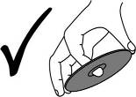
Avoid touching the playing surface of discs for it may damage the disc surface.

- Cleaning Discs
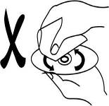
Fingerprints or stain on the disc may affect the quality of sound and picture. Gently wipe the surface of disc by clean soft cloth for cleaning purpose. Moisten a soft cloth with diluted neutral detergent to remove heave dirt or fingerprints if necessary.
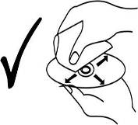
Do not wipe in a circular motion (concentric scratches on the disc surface tend to cause noise). Gently wipe from the center of the disc to the outer edge as the right figure.

- General Operation

Please read through the instructions below before opearting Prestigio PPDP 370 Twin for the first time.
WARNING:
Do NOT play poor quality discs for it will damage the lens.

  - Before Playing

  - Connect Prestigio PPDP 370 Twin to power supply or wall plug via power adapter provided.
  - Turn on unit by sliding power switch at the left side of unit to ON position.
  - Press OPEN button to open disc tray cover. Place the disc in the disc tray with printing side face up. Close the disc tray cover.
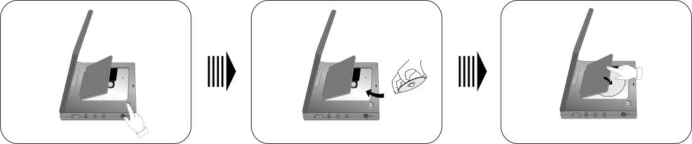
  - The device will automatically begin disc playback process.
  - Adjust the volume by scrolling volume control at the right side of unit to an appropriate level before playback.
  - Turn off unit by sliding power switch at the left side of unit to OFF position.

  - Adjusting Screen Aspect Ratio

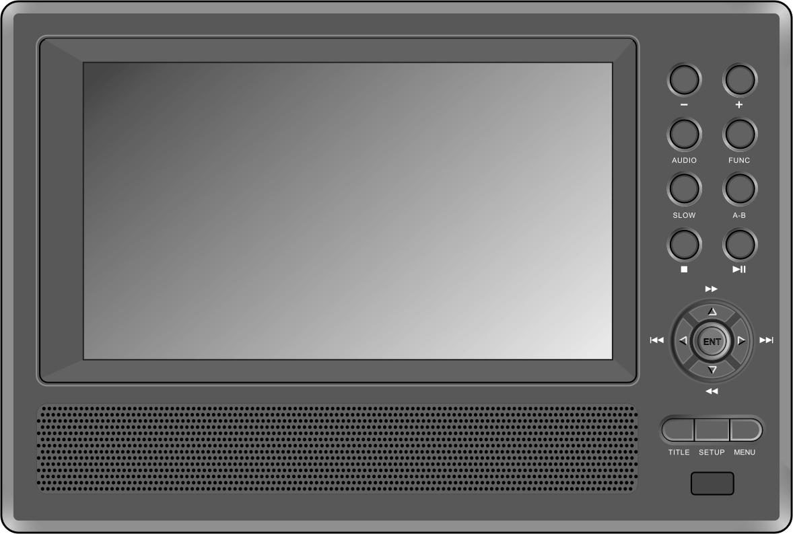
Press the FUNC button to change the brightness and color level. Adjust these values with + and - buttons on the front panel. Press and hold the FUNC button to change the screen aspect ratio between 16:9 and 4:3. Refer below images for simple illustration.
FUNC button
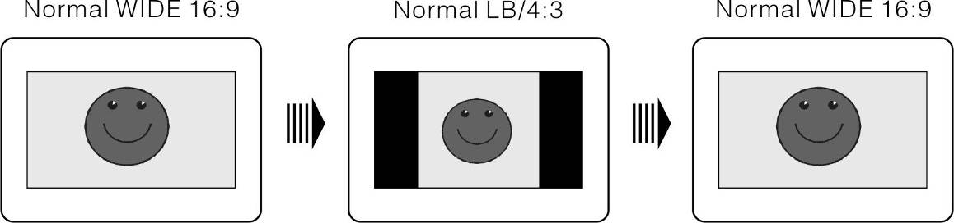
- DVD Disc Playback Operations

ENTER/ENT button
Press ENTER/ENT button to start playback. Press ▲▼►◄ directional buttons or press 0-9 buttons to select a title/chapter directly.
PAUSE/
Button
Press PAUSE/
button to pause during playback and press PLAY/
button to resume playback.

STOP/ button
During playback, press Stop/ button once to stop playing. Press PLAY/
button to resume normal playback from the stopped point. Press STOP/ button twice to stop playback completely. Then press PLAY/
button to start playback from the beginning of file.
ZOOM button
Press ZOOM button repeatedly to cycle through 1X, 2X, 3X zooming effects and normal playback.

A-B button
Press A-B button once to set the starting point A, press it again to designate end point B. The segment from A to B will be played repeatedly. Press the button again to stop A-B repeat function.

TITLE button
Press TITLE button during playback to return to title screen. Press the ▲▼►◄ directional buttons to select the title/chapter to start playback, and press the ENTER/ENT button to confirm selection, or press 0-9/+10 buttons to select specific title/chapter directly.

MENU button
Press MENU button during playback to return to main menu. Press ▲▼►◄ directional buttons to select the title/chapter to start playback, and press the ENTER/ENT button to confirm selection, or press 0-9/+10 buttons to select specific title/ chapter directly.

/ buttons
Press  button to go to the previous chapter.
Press  button to skip to the next chapter.

/ buttons
Press  button to fast forward through the file. Press it repeatedly to fast forward at the speed of 2X, 4X, 8X, 16X and normal playback in sequence. Press  button to rewind. Press it repeatedly to rewind at the speed of 2X, 4X, 8X, 16X and normal playback in sequence.
Press the PLAY/
button to resume normal playback.
SLOW button
Press SLOW button during playback to view in slow mode. Press it repeatedly to slow playback at the speed of 1/2, 1/4, 1/6, 1/8 and normal playback in sequence. Press PLAY/
button to resume normal playback during slow mode.
INFO button
Press INFO button to display detailed file information. Press again to cancel.

AUDIO button
Up to 8 audio bit streams are recordable in DVD discs. Press AUDIO button during playback to select the preferred audio bit stream. The unit will display the next audio bit stream available in the DVD disc every time the button is pressed
NOTE: This function is only available for DVD discs that contain multi-audio languages.

SUBT button
Press SUBT button to cycle through available subtitle languages or to turn off the subtitle during playback. A DVD disc can be recorded with up to 32 subtitles.
NOTE: This function is only available for DVD discs that support multi-subtitles

REP button
Press REP button to cycle through repeat patterns including chapter repeat, title repeat or cancel repeat.
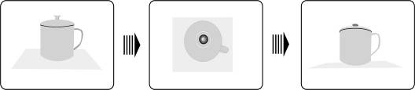

ANGLE button
Press ANGLE button to play the disc in multi-angle mode. Multi-angle mode allows a scene to be viewed from different angles (files with multi-angle feature only). Refer to the example below:

Press ANGLE button to select the angle desired. Press the button repeatedly to cycle through different viewing angles if there are multiple angles in a scene.
NOTE: This function is only available for the DVD discs coded with multi-angles.

GOTO button
Press GOTO button to select desired disc title, chapter or time to start playback. Use the ▲▼ directional buttons to highlight Title, Chapter or Time. Use 0-9/+10 number buttons to input numbers of the desired title, chapter or time and press ENTER/ENT button to confirm.
Press the button again to cancel playback.

- CD Disc Playback Operations

A CD disc will be automatically loaded when placed in the unit. A playback menu will be displayed on the screen and the files in the disc will be played automatically by the default sequence of the disc. Press / buttons to select the desired track or press the 0-9/+10 number buttons to input the number of the desired track and press ENTER/ENT button to confirm for playback.

PAUSE/
button
Press PAUSE/
button to pause during playback and press PLAY/
button to resume playback.

STOP/ button
During playback, press Stop/ button once to stop playing. Press PLAY/
button to resume normal playback from the stopped point. Press STOP/ button twice to stop playback completely. Then press PLAY/
button to start playback from the beginning of file.

/ buttons
Press  button to fast forward through the file. Press it repeatedly to fast forward at the speed of 2X, 4X, 8X, 16X and normal playback in sequence. Press  button to rewind. Press it repeatedly to rewind at the speed of 2X, 4X, 8X, 16X and normal playback in sequence.
Press the PLAY/
button to resume normal playback.
/ buttons
Press  button to go to the previous chapter.
Press  button to skip to the next chapter.
REP button
Press REP button to cycle through repeat patterns including chapter repeat, title repeat or cancel repeat.

A-B button
Press A-B button once to set the starting point A, press it again to designate end point B. The segment from A to B will be played repeatedly. Press the button again to stop A-B repeat function.

GOTO button
Press GOTO button to select desired disc title, chapter or time to start playback. Use the ▲▼ buttons to highlight Title, Chapter or Time. Use 0-9/+10 number buttons to input numbers of the desired title, chapter or time and press ENTER/ENT button to confirm.
Press the button again to cancel playback.

- JPEG File Viewing Operations

- Before Viewing JPEG Files

A disc with JPEG files will be automatically loaded when placed in disc tray,
The root folder with several subdirectories/subfolders will be displayed. Press ENTER/ENT button to enter. Use ▲▼ buttons to select a desired folder and press ENTER/ENT button to confirm selection.
Upon entering the selected subfolder, pictures with JPEG format will be displayed. Press ▲▼ buttons to select the desired picture and press ENTER/ENT button to start playback.
Press ▲▼ buttons to highlight , press ENTER/ENT button to return to the last folder or directory.
NOTE: Discs may contain files other than JPEG files.

- Filter and Repeat Setup
Under the folder mode, press the ▲▼►◄ directional buttons to highlight FILTER. Please follow steps below to change its settings:
Press ENTER/ENT button to enter the setup menu.
Press ▲▼ buttons to select the options desired for setting.
Press ENTER/ENT button to select or cancel.
Press ◄ button to exit.

Under the folder mode, press ▲▼►◄ directional buttons to highlight REPEAT and press ENTER/ENT button or REP button on the remote control to cycle through settings.

STOP/ button

Press Stop/ button to return to the folder mode during playback. Press PLAY/
button to resume normal playback

PAUSE/
button
Press PAUSE/
button to pause during playback and press PLAY/
button to resume playback.

/ buttons
Press  button to go to the previous picture.
Press  button to skip to the next picture
REP button
Press REP button to cycle through repeat patterns including single repeat, folder repeat or cancel repeat.
Picture Rotate

During browsing a picture, use ▲▼►◄ directional buttons to rotate the current picture.
Press ► button to rotate the current picture 90° clockwise, as shown below:

Press ▼ button to rotate the current picture 180° clockwise, as shown below:

Press ◄ button to rotate the current picture 270° clockwise, as shown below:

- System Setup

Please follow below procedures to change the default settings to customize its performance to user preference.

Follow the steps below to set up device:
Press SETUP button and the setup menu will be displayed on the screen.
Press ◄/► buttons to select between menu tabs desired for setup. Press ENTER/ ENT or ▼ button to enter the menu or confirm.
Press the ◄ button to return to the previous menu. Or press the SETUP button again at any time during the setting to exit from the setup menu.

- Language setup

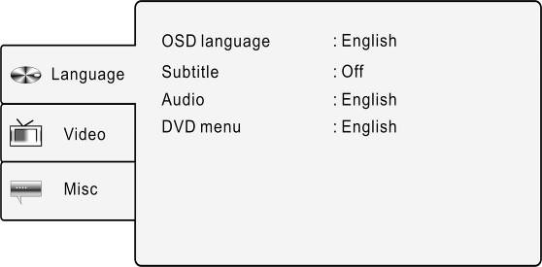 | Press SETUP button and press ▲▼ buttons to select Language tab. The screen will be displayed as shown at left.
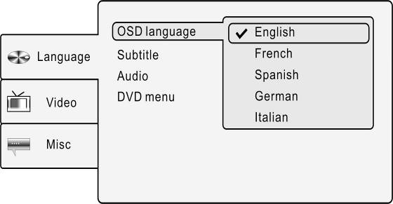 | 1. OSD language  Select the option to setup OSD (On-Screen Display) language.  Press ▲▼ buttons to highlight OSD language and press ENTER/ ENT or ► button to confirm. Press ▲▼ buttons to select preferred language and press ENTER/ENT button to confirm selection and return.
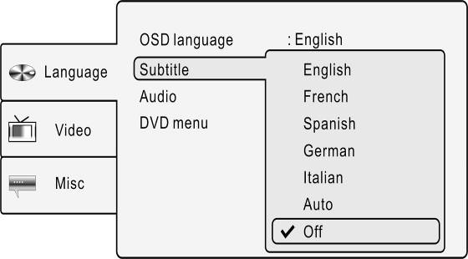 | 2. Subtitle  Select the option to adjust the subtitle language. Press ▲▼ buttons to highlight Subtitle and press ENTER/ ENT or ► button to confirm. Press ▲▼ buttons to select preferred subtitle language and press ENTER/ ENT button to confirm selection and return
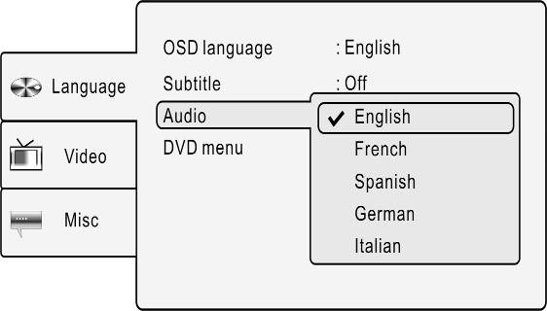 | 3. Audio  Select the option to adjust audio output language. Press ▲▼ buttons to highlight Audio and press ENTER/ ENT or ► button to confirm. Press ▲▼ buttons to select desired audio output language and press ENTER/ ENT button to confirm selection and return.
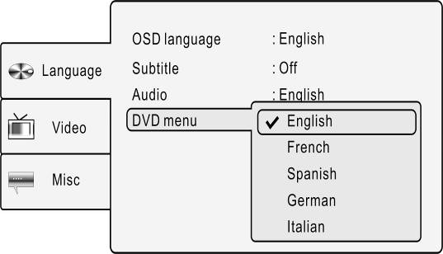 | 4. DVD menu  Select the option to setup disc menu language. Press ▲▼ buttons to highlight DVD menu and Press ENTER/ ENT or ► button to confirm. Press ▲▼ buttons to select desired DVD menu language and press ENTER/ ENT button to confirm selection and return.

- Video setup

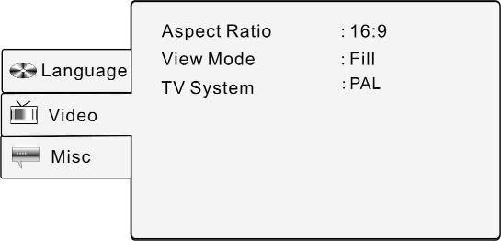 | Press SETUP button and press ▲▼ buttons to select Video tab. The screen will be displayed as shown at left.
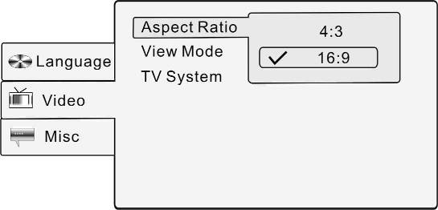 | 1. Aspect Ratio  Select the option to setup aspect ratio. Press ▲▼ buttons to highlight Aspect Ratio and press ENTER/ ENT or ► button to confirm. Press ▲▼ buttons to select between 4:3 and 16:9 and press ENTER/ENT button to confirm selection and return.
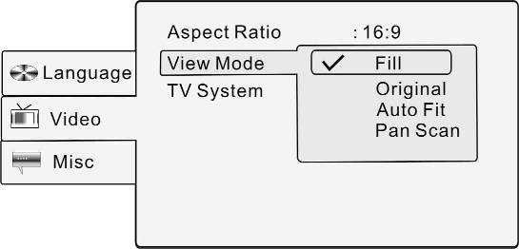 | 2. View Mode  Select the option to adjust the viewing mode of screen display. Press ▲▼ buttons to highlight View Mode and press ENTER/ ENT or ► button to confirm. Press ▲▼ buttons to select appropriate viewing mode and press ENTER/ ENT button to confirm selection.
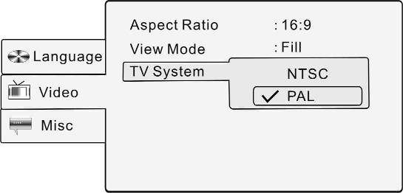 | 3. TV System  Select the option to conform to TV standard. Press ▲▼ buttons to highlight TV System and press ENTER/ ENT or ► button to confirm. Press ▲▼ buttons to select appropriate TV system and press ENTER/ ENT button to confirm selection and return.
- Misc setup

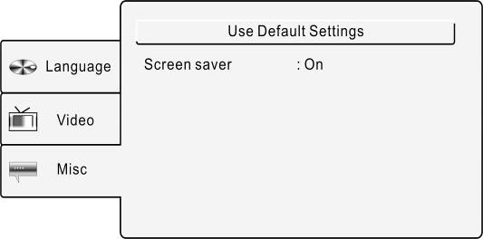 | Press SETUP button and press ▲▼ buttons to select Misc tab. The screen will be displayed as shown at left.
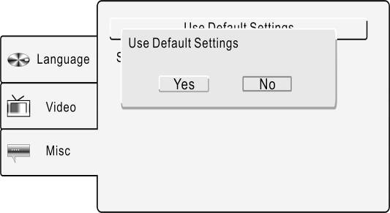 | 1. Use Default Setting  Select the option to restore default settings. Press ▲▼ buttons to highlight Use Default Setting and press ENTER/ ENT or ► button to confirm. Press ▲▼ buttons to select Yes and press ENTER/ENT button to confirm selection or Press No to cancel.
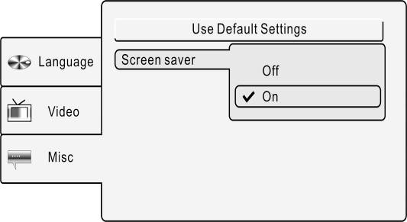 | 2. Screen Saver  Select the option to turn on/off screen saver. Press ▲▼ buttons to highlight Screen saver and press ENTER/ ENT or ► button to confirm. Press ▲▼ buttons to select On or Off and press ENTER/ ENT button to confirm selection and return

- Using Straps

Follow the steps below to attach the Prestigio PPDP 370 Twin onto the car seat headrest.
- Place the unit on a soft and smooth surface with the bottom facing up.
- Loosen up the strap and remove the buckle from the strap.
- Insert the strap through the hole as demonstrated in Fig.1. Make sure the inner side of the strap faces up.
- Ease the strap into the buckle as demonstrated in Fig.2 and Fig.3. Before putting the unit onto car seat headrest, please make sure the outer side of the buckle faces up.

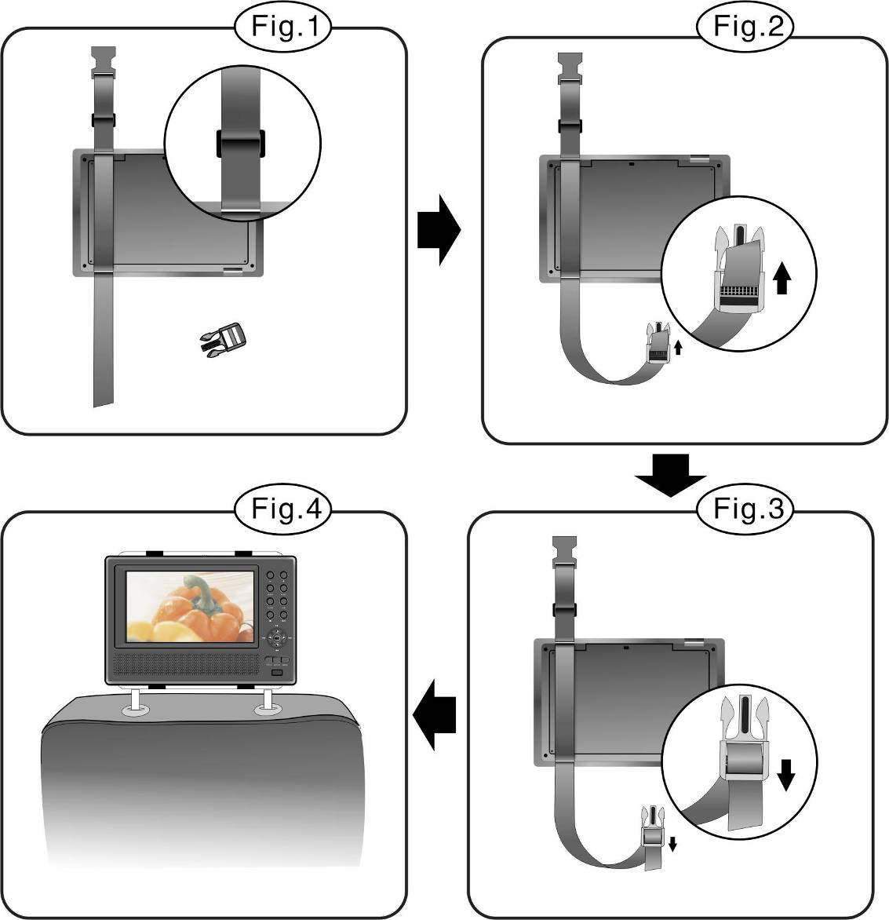

- Repeat above steps for the other strap.
- Adjust the length of the straps to fit the car seat headrest.
- Fasten the straps on the headrest as in Fig.4. Make sure the two straps are between the headrest supporting metal rods.

NOTE: The drawings below illustrate the outside and the inside of the buckles and the straps.

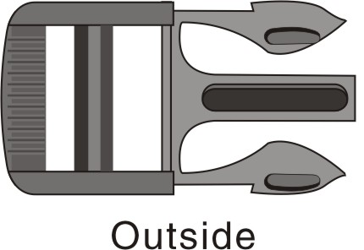 | 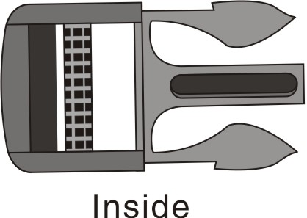
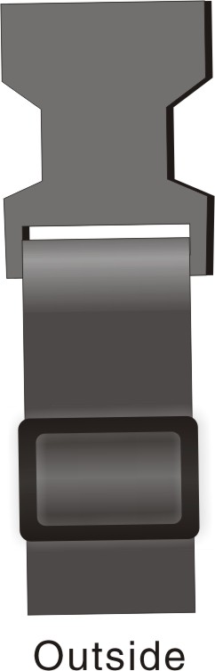 | 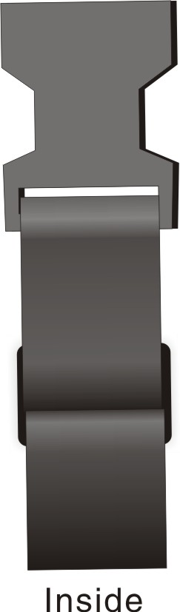

- Troubleshooting

Take steps described in the tables below to solve simple problems before contacting customer service.
WARNING:
Immediately turn off the unit and disconnect the power adapter if the unit is not working properly. Never try to repair the unit without authorized professionals for it may damage the unit.

PROBLEM | POSSIBLE CAUSE | POSSIBLE SOLUTION
The unit does not interact with discs | The disc cover is not properly closed. | Close the disk cover and press firmly to ensure fully closure.
The unit does not interact with discs | There is not disc in the disc tray. | Place a disc with playable format files.
The unit does not interact with discs | The disc is not placed with label side facing up. | Place the disc with label side facing up.
The unit does not interact with discs | The disc may not be clean or scratched. | Clean the data side of disc to prevent mis-reading.
The unit does not interact with discs | The disc region code may not match that of the unit. | Make sure the both region code match.
The unit does not interact with discs | There is liquid on the lens. | Remove the disc and keep the unit powered off for at least 2 hours.
There is no sound. | The connection between the unit and audio system is bad. | Re-connect the audio system and the unit and make sure the connection is secured.
There is no sound. | The speaker may be off. | Turn on the speaker.
There is no sound. | The sound of the disc may not be setup correctly. | Try setup the disc sound again.
There is no sound. | The disc may not be clean or scratched. | Clean the data side of disc to prevent mis-reading.
There is no picture. | The LCD panel may be off or not in proper video mode. | Turn on the LCD panel or adjust to a proper video mode.
There is no picture. | The connection between the unit and video system is bad. | Re-connect the video system and the unit and make sure the connection is secured.
There is no picture. | The unit is not in AV OUT mode. | Switch AV Switch at the bottom of the unit to AV OUT.
Poor AV performance. | The disc may not be clean or scratched. | Clean the data side of disc to prevent mis-reading.
The remote control is not functioning properly or not working at all. | There may be obstacles between remote control and the receiving port on the unit. | Remove obstacles between remote control and the receiving port on the unit.
 | The remote control in not aligned with the unit | Try pointing the remote control towards the receiving port on the unit.
 | The battery on the remote control is not properly inserted. | Adjust the battery position in the remote control as instructed.
 | The battery in the remote control is weak or depleted. | Replace the battery.

WARNING:
Static or other external interference may cause Prestigio PPDP 370 Twin DVD Player to function abnormally. In order to remove abnormality, please unplug the power cord and then plug it into the outlet again to reset the device. If the problem persists, please unplug the power cord and consult local service center or the qualified technician.

- Appendix

  - Product Specification
TFT screen size |  | 7.0 inches
Laser Wavelength |  | 780/650 nm
Video System |  | PAL
Frequency Response |  | 20Hz～20kHz ±2.5dB
Audio Signal-to-Noise Rate |  | ≥85dB
Audio distortion + noise |  | ≤－70dB (1kHz)
Channel Separation |  | ≥70dB (1kHz)
Dynamic Range |  | ≥80dB (1kHz)
Audio Out | Analog Audio Out | Output Level: 1.5V±0.2 1.0, Load: 10KΩ
Video Out | Video Out | Output Level: 1V_{P-P}±0.2, Load: 75Ω  Unbalanced Negative
Power |  | DC 12V
Power Consumption |  | < 25W
Dimensions (L*W*D) |  | 230mmX154mmX40mm (Main Unit)  230mmX154mmX22mm (2nd Monitor)
Weight |  | Approximately 0.85kg (Main Unit)  0.53kg (2nd Monitor)

  - Technical Support and Warranty Information

Please refer to www.prestigio.com for technical support and warranty information.

  - Disclaimer
We make every effort to ensure that the information and procedures in this user manual are accurate and complete. No liability can and will be accepted for any erros or omissions. Prestigio reserves the right to make any changes without further notice to any products herein.

