Prestigio LCD PC Officer 375/595

USER’s GUIDE

Notice
The company reserves the right to revise this publication or to change its contents without notice. Any changes therefore will be incorporated in further editions or special supplements. Information contained herein is for reference only and does not constitute a commitment on the part of the manufacturer or any subsequent vendor. They assume no responsibility or liability for any errors or inaccuracies that may appear in this publication nor are they in anyway responsible for any loss or damage resulting from the use (or misuse) of this publication.

This publication may not, in whole or in part, be reproduced, translated, transmitted or reduced to any machine readable form without prior written consent from the copyright owner – Prestigio Company.

Brand and product names mentioned in this publication may or may not be copyrights and/or registered trademarks of their respective companies. They are mentioned for identification purposes only and are not intended as an endorsement of that product or its manufacturer.
IMPORTANT SAFETY INSTRUCTIONS
1. Read all of the following safety instructions.
2. Save these instructions and the user manual for later use.
3. Always unplug this monitor from the wall outlet before cleaning. Do not use liquid cleaners or aerosol cleaners. Use a damp cloth for cleaning. You can also use special cleaners for LCD monitors.
4. While connecting this device to a wall outlet, make sure it has proper power specifications.
5. Depending on the country of purchase the power adapter may have either a 2-prong or a 3-prong grounded plug. The third prong is an important safety feature; do not defeat its purpose. Don’t plug in the device to a non-grounded outlet. If you do not have access to a compatible outlet, have a qualified electrician install one.

Warning! The grounding plug is an important safety feature. Don’t use a non-grounded outlet as it may possibly result in fire, electric shock, and injury to persons.

Note: The grounding plug also provides protection in case of interference caused by other electrical appliances connected to the same power supply network.

6. Follow all warnings and instructions marked on the case of the device.
7. Slots and openings in the cabinet are provided for ventilation, to ensure reliable operation of the device, and to protect it from overheating. These openings must not be blocked or covered. The openings should never be blocked by placing the device on a bed, sofa, rug, or other similar surface. This device should never be placed near or over a radiator or heat register. This device should not be placed in a built-in installation unless proper ventilation is provided. This device should be placed vertically on the stand.
8. Do not spill water or liquid on the computer as it may result in fire or electric shock.
9. Don’t try to open the case of the device. Refer all servicing to qualified service center specialists.
10. Unplug this device from the wall outlet and refer servicing to qualified service personnel under the following conditions:
a. If liquid has been spilled into the cabinet.
b. If the device has been exposed to rain or water.
c. If the device does not normally when you follow the operating instructions.
d. If the device has been dropped or the cabinet has been damaged.
e. When the device exhibits a distinct change in performance, this indicates a need for service.
11. Don’t use the device under high environment temperature. When the air temperature is over 35⁰C there is a risk of malfunction.
SERVICING
Do not attempt to service this device yourself, as opening or removing covers may expose you to dangerous voltages or other hazards. Refer all servicing to qualified service personnel.
Unplug this device from the wall outlet and refer servicing to qualified service personnel under the following conditions:
a. When the power cord or plug is damaged or frayed.
b. If the device has been exposed to rain or water.
c. If the device has been dropped or the cabinet has been damaged.
d. If the device does not normally even when you follow the operating instructions.
Overview of Prestigio LCD PC Officer 375/575
Prestigio LCD PC Officer is a functional easily upgradeable working place for enterprises, research and development organizations, educational establishments, trade and finance organizations, etc. LCD PC is characterized by a single block design: the PC is combined with a 17" or 19" LCD monitor (depending on the model) that provides 40% of more free working space due to the absence of a system block and connecting cables.
The modern design of the device makes it ideal for any office interior due to a slim display frame, multifunctional stand with built-in speakers, electronic components and a compartment for office supplies.
Due to Intel® Mobile-on-Desktop technology the device is characterized by low noise level and low power consumption.
Technical support
Our company constantly improves the quality of Prestigio LCD PC Officer. To check the latest modifications and functions you can visit the web-pages of Prestigio.
Country | Web-page
International | www.prestigio.com
Belarus | www.prestigio.by
Bulgaria | www.prestigio.bg
Croatia | www.prestigio.com.hr
Cyprus | www.prestigio.com
Czech Republic | www.prestigio.cz
Egypt | www.prestigio.com
Estonia | ee.prestigio.com
Hungary | www.prestigio.hu
Ireland | www.prestigio.com
Kazakhstan | www.prestigio.com.kz
Lithuania | www.prestigio.lt
Morocco | www.prestigio.com
Netherland | www.prestigio.com
Poland | www.prestigio.pl
Portugal | www.prestigio.pt
Romania | www.prestigio.ro
Russian Federation | www.prestigio.ru
Serbia | yu.prestigio.com
Slovak Republic | www.prestigio.sk
Slovenia | www.prestigio.si
South Africa | www.prestigio.com
Turkey | www.prestigio.com
Ukraine | www.prestigio.ua
United Arab Emirates | www.prestigio.com

Package Contents
The package of Prestigio LCD PC consists of:

1. Prestigio LCD PC Officer 375/595 Device
2. External power adapter (19V 90W) with a power cable
3. Keyboard
4. Mouse
5. Wi-Fi antenna *
6. CD (with drivers and user’s guide)
7. Warranty card
8. User’s guide
9. Packing

Note! The package contents of your LCD PC model may be different from the mentioned above.

Unpacking
1. LCD PC is delivered in a cardboard box. Be careful while unpacking it. If you see any signs of breakage or some package components are missing consult your dealer.
2. Carefully take all the accessories out of the cardboard box.
3. Carefully take the LCD PC out of the cardboard box, remove the packaging and place the device on a stable horizontal surface.
4. Unpack the accessories.
Setup and start-up
1. Connect the keyboard and mouse to USB ports at the rare of LCD PC (see ‘Rare view’).
2. In case of necessity (and when wireless network is available) connect Wi-Fi antenna to a corresponding jack at the left of LCD PC.
3. In case of necessity you may also connect a LAN cable.
4. Connect a power adapter to a corresponding jack (see ‘Rare view’).
5. Connect a power adapter to an electric outlet (220V AC) with a help of the provided power cable.
6. Press the ON/OFF button of LCD PC (see ‘Front view’).

Having followed all the mentioned above instructions you will see Windows OS welcome screen.

You can also use this page to note down the model number, serial number, the date and place of purchase. Model number and serial number of your Prestigio LCD PC Officer are marked at the label on the device. If you have any problems with your Prestigio LCD PC Officer you will need to provide its model number and serial number, the date and place of purchase.

Model number:

Serial number:

Date of purchase:

Place of purchase:

Caution: Changes or modification to the given equipment not directly approved by the manufacturer may limit or void your warranty.
Basic components
Front view
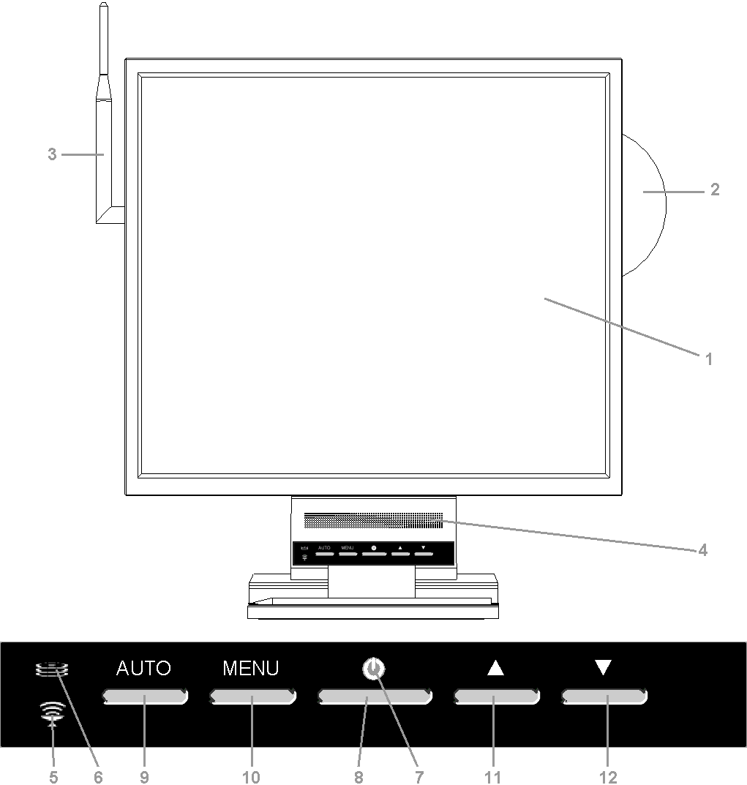

1. 17" or 19" LCD
2. CD
3. Wi-Fi antenna
4. 2х 2W speakers
5. Wi-Fi LED
6. Hard drive LED
7. LCD PC LED
8. ON/OFF button for LCD PC.
9. Picture auto-adjust button
10. Monitor MENU button
11. Menu navigation button "+", "/\"
12. Menu navigation button "–", "\/"
Right view
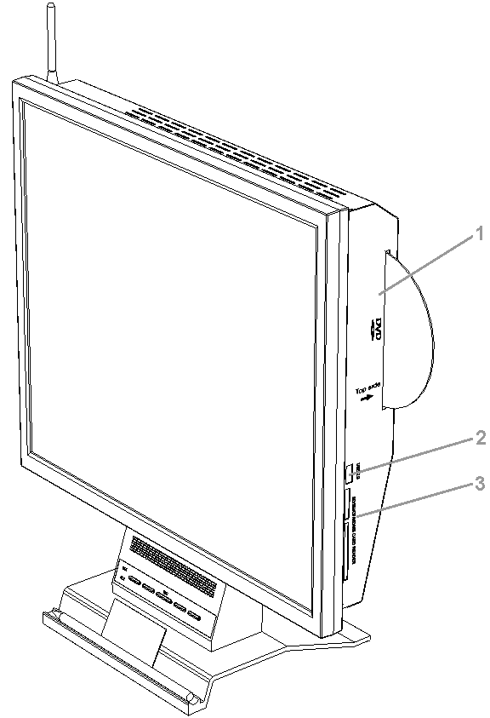

1. Multifunctional CD/DVD RW optical drive.

NOTE! The optical drive with slot loading does not support 80-mm CDs! To avoid malfunction or disk jam, do not use 80-mm CDs.

2. Additional USB2.0 port.
3. Universal card-reader SD/SM/CF/MD/MS.
Rare view
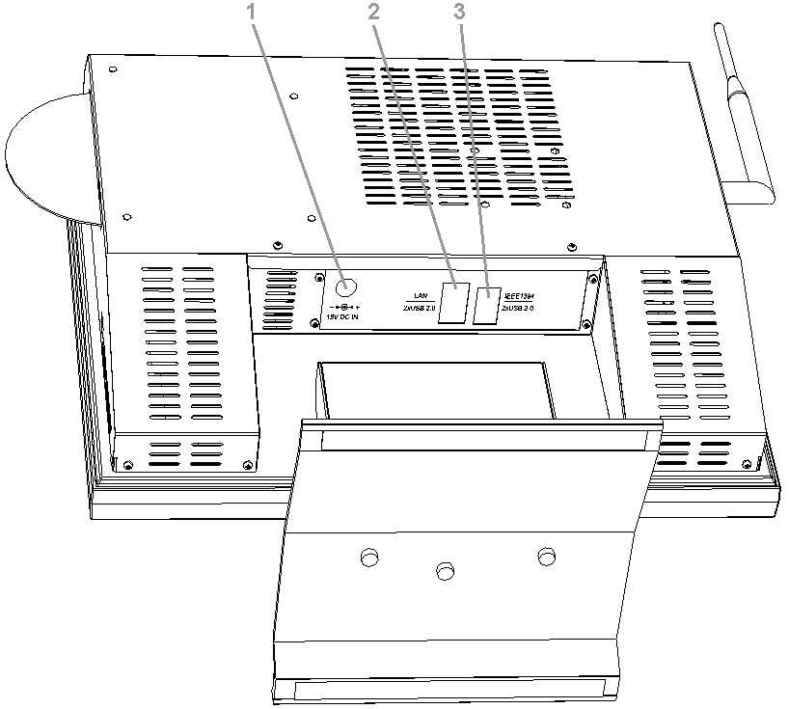

1. DC-in (19V 90W).
2. LAN port and 2 USB2.0 ports.
3. IEEE1394 port and 2 USB2.0 ports.
On-Screen Display
With a help of On-Screen Display menu (OSD) you can change brightness, contrast, color temperature of image and volume level of speakers. The menu is shown on the picture below.

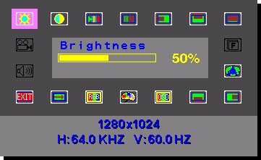

1. OSD can be loaded with a help of MENU button (see ‘Front view’). At the bottom of the screen you will see the current resolution and refresh rate.
2. With a help of /\ and \/ buttons you can choose a necessary submenu. The submenu is shown in the center of the OSD screen.
3. Use MENU button to select the submenu for modification.
4. Use buttons /\ and \/ to modify the selected value.
5. Press MENU button to save new settings and continue adjustment procedures.

All the performed changes will be saved automatically several seconds after the last changes have been made. The OSD screen will then disappear.

OSD contains the following submenus:
Submenu | Description
Brightness | Adjust the brightness of image.
Contrast | Adjust the contrast of image.
Clock/ Phase | Adjust the clock and phase of the screen image.
H.Position/V.Position | Adjust the position of the display horizontally and vertically.
Auto Adjust | Choose automatically the proper horizontal position and vertical position & size of the screen image.
Language | Select language for the OSD.
OSD H.Position/ OSD V.Position | Adjust the OSD position on the screen.
Translucent | Adjust the OSD transparency.
Color Temperature | Choose different color temperature.
Reset | Reset the screen to the Factory Preset Display Settings.
Exit | Exit the OSD.
Volume | Increase or decrease audio volume.

