User’s Manual
USB2.0 HDD Enclosure
Hi-Storage
Personal Backup

INDEX
PART I HDD ENCLOSURE OPERATING INSTRUCTIONS
- Getting Start
- Product Feature Highlights
- What’s in the Package
- System Requirements
- Product Views and Description
- Install Driver for Windows 98 Environment

PART II Hi-Storage – the Data Security Tool
- Plug and Play
- Read and Write
- Unplug
- Security Area Only (Single Partition)
- Install the USB Driver:
- Use Hi-Storage for the First Time
- Hi-Storage - Create Partition
- Login the Security Area
- Logout the Security Data Zone
- Manage Password

PART III One-Touch Backup (OTB) -- the “Personal Backup”
- How to install “Personal Backup”
- Exit the program
- Personal Backup
- Personal Backup Settings
- [Add] new sync items
- Copy synchronization item
- Edit synchronization item
- Delete synchronization item
- Log Options
- Test Run Options
- Save and Apply
- Personal backup advanced settings
- Start scheduled sync
- Run Sync now

Appendix
PART I HDD ENCLOSURE OPERATING INSTRUCTIONS

- Getting Start
Thank you for purchasing Prestigio Leather HDD Enclosure product. The product presents you a new concept of mobile storage of you computer data with safety and conveniences. Please read this manual thoroughly before you start using the product, and follow all of the procedures in the manual to use the product correctly.

Safety Precautions
Please follow the safety precautions carefully before you use the Hi-Storage device. Make sure that you use the device correctly according to the procedures described in this manual.

Warnings: This mark indicates actions that could lead to serious injury to your body or damage to the device if ignored or handled incorrectly.
___________________________________________________________________
Warnings
_____________________________________________________________ _
- Do not attempt to disassemble or alter any part of the device that is not described in this guide.
- Do not allow the device to come into contact with water or other liquids. In the event that water or other liquids enter the interior, immediately unplug the device from the computer. Continued use of the device may result in fire or electrical shock. Please consult your product distributor or the closest support center.
- To avoid risk of electrical shock, do not plug or unplug the device with wet hands.
- Do not place the device near a heat source or expose it to direct flame or heat.
- Never place the device close to equipment generating strong electromagnetic fields. Exposure to strong magnetic fields may cause malfunctions or data corruption.

- Product Feature Highlights
  - Classic Leather Coated Craftsmanship –
It brings luxury and simplicity into your daily computing lives.
  - Data Security (the “Hi-Storage”)
With H-Storage application software, you can protect your device with password log-in and partition your device into “Public” and “Security” Areas.
- Public Area There is no password protection to this area. You can do any basic functions described in the “Basic Functions” section, in this area.
- Security Area This area cannot be accessed without security log-in. Once you log in, the device will be switched from “Public Area” to “Security Area”. After successful switching, you can do any basic functions described in the “Basic Functions” section, in this area.
You can only view either “Public Area” or “Security Area” at the same time in the same disk logic unit number (Drive).

- One-Touch Backup (the OTB)
This feature enables you to save you data in your computer and in the HDD enclosure simultaneously.

- What’s in the Package
- Leather HDD Enclosure Main Unit 1
- USB Cables 2
- Leather Carry Case 1
- User’s Manual 1
- Driver and Software CD 1
- Screws and Screw Driver

4. System Requirements -- There are minimum hardware and software requirements that must be satisfied to ensure the device function properly.
- Computer -- BM PC/AT Compatible, Power Macintosh, PowerBook, iMAC or iBook
- Operating System -- Windows 98 Second Edition, Windows Millennium Edition (Windows ME), Windows 2000, Windows XP, Windows 2003 Server, Linux 2.4 or above, Mac OS 9.0 or above
- Memory： Minimum 32MB of RAM
- User Authority: Administrator (Manager)
- USB Port
- Free Hard Disk Space -- No less than 16 MB(3MB for Win98 driver, 3MB for Hi-Storage, and 10MB for Personal Backup application)
  - Windows 98 SE does not support default Mass Storage Driver. Please install the driver in the CD of the product package.

5. Product views & description

Top View Front View
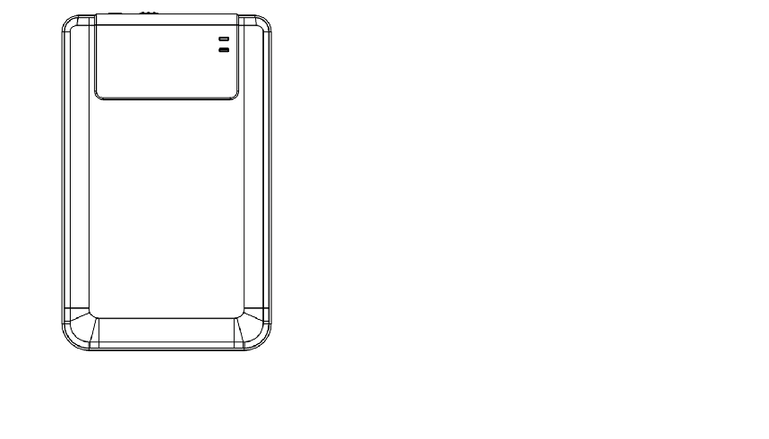
POWER LED
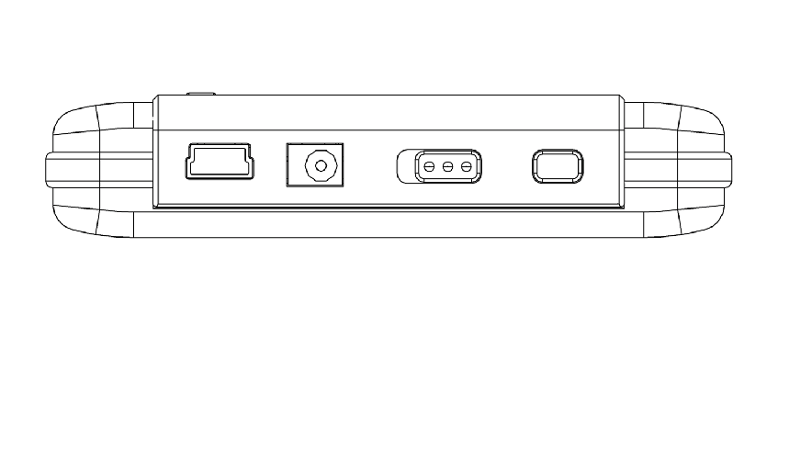

R/W LED

USB DC POWER COPY
PORT ON/OFF

6. Install Driver for Windows 98 Environment
To run the product under Win98 environment, please install the Win98 driver contained in the CD of the product package
- Turn on the computer
- Connect the HDD enclosure to the USB port of the computer
- Put the CD into the CD ROM drive of the computer
- Win98 will automatically detect the HDD enclosure device and show the dialog box “Add New Hardware”. Then follow the instruction shown on the dialog box on the computer screen.
PART II Hi-Storage – the Data Security Tool

Basic Functions
- Plug and Play
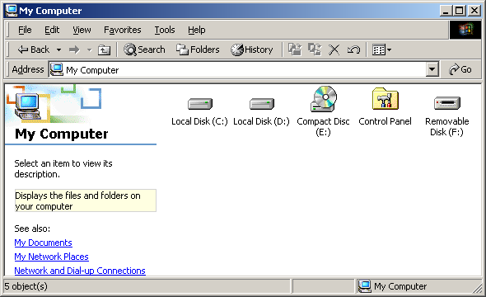

When you plug the device into the USB port of your computer, you will see a “Removable Disk” icon in the file manager window. In Macintosh, once you plug the Hi-Storage into the USB port. You can see the disk icon in the “Desktop”.

In Linux OS, you can mount the device by the following instructions.
■ Execute cd/etc/sysconfig/ (cat/etc/sysconfig/hwconf | more)
■ Check the device information in hwconf，write down the mount point.
■ Make a directory in/mnt (ex: mkdir/mnt/usbHD)
■ Then, execute mount/dev/sda1 /mnt/usbHD (if mount point was .dev/sda)

- Read and Write
You can retrieve or store files in the device as a hard disk. The read/write operation of the device is the same as that of a hard disk.

- Unplug
To minimize risk of data loss on Windows ME and 2000, please follow the safe removal procedure. You can find the safe removal icon in your computer’s notification area.
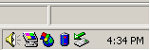

Double click the “safe removal” icon; the “Unplug or Eject Hardware” window will pop up. You can select the device you want to remove. Then, click the [Stop] button. After that, you can unplug the device from the USB port of your computer.

Warning: Before removing the Hi-Storage device, make sure the LED is not flashing. When the LED flashes quickly, there is some traffic going on between the host computer and the Hi-Storage device. Don’t remove the Hi-Storage at this moment. Otherwise, it may cause some damages to the data or even the Hi-Storage device itself.

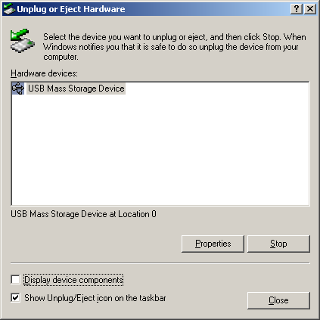
Warning: If you do not follow the safe removal procedure on Windows ME and Windows 2000 operating systems, data loss caused by the “write cache” issue may happen.

On Macintosh operating systems, you can drag the removable disk icon into the trash. This action will perform the “Eject” function.

On Linux operating system, please follow the “demount” procedure to demount the device.

Partition Type
With Hi-Storage application software, you can protect your device with password log-in and partition your device into “Public” and “Security” Areas.
1. Public Area There is no password protection to this area. You can do any basic functions described in the “Basic Functions” section, in this area.
2. Security Area This area cannot be accessed without security log-in. Once you log in, the device will be switched from “Public Area” to “Security Area”. After successful switching, you can do any basic functions described in the “Basic Functions” section, in this area.
          - You can only view either “Public Area” or “Security Area” at the same time in the same disk logic unit number (Drive).

- Security Area Only (Single Partition)
Partition the device into two areas in one Drive: Public Area and Security Area. The Public Area is read only. The Security Area can be accessed only with a correct password.

Please refer to the figure below.
This figure shows detailed operations of single Drive.

Use the H-Storage Software
On the Windows Platform
- Install the USB Driver:
- In Windows 98 SE, you need to unplug and re-plug the Hi-Storage device after installing the driver.
For Windows NT systems, users should log on as the Administrator to run this program.

- Use Hi-Storage for the First Time:
Warning: H-Storage.exe can only handle one device at the same time. If otherwise, the H-Storage.exe may not perform properly or even cause data loss.
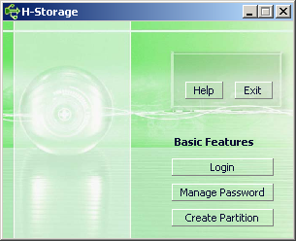

By default, the device is non-security. So, the “Create Partition” function will be activated when you run this software for the first time.

- Hi-Storage - Create Partition:
You can do the [Create Partition] action to your H-Storage.

Warning: The [Create Partition] action will erase all the data in the device. The action is not reversible. If necessary, please back up your data, and close all the active programs and windows on the screen of your computer before running this action.

  - Click the [Create Partition] button in the H-Storage manager window. The following “Create Partition” window will pop up.

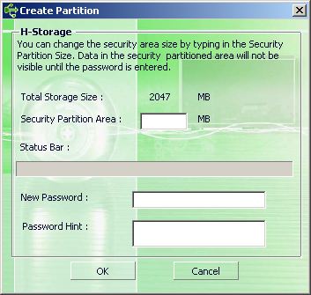

  - You can key in a hint for your new password in the “Password Hint” box. This hint will be displayed when you click the “Hint” button in the “Login” window. The maximum length of the Hint is 32 characters. After you finished the setting, click the [OK] button. The “Confirmation” window will pop up.
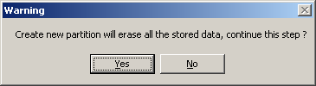

  - Once the resizing is finished, the following message will pop up.
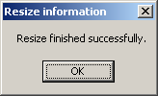

- Login the Security Area:
If you partition the device with security, you can execute the following “Login” function to access the security Area.
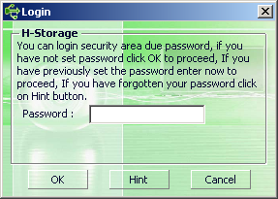

Warning: When you do the login and logout actions with the device, please make sure there is no application or program running or document unclosed on the device. Otherwise, it may cause data loss or damage.

8-1 Key in the password in the “Password” area.
- You can create the password hint in the [Create Partition] or [Manage Password] functions. Once you create the password hint, you can click on the “Hint” button in the “Login” window to help you recall the correct password. The hint will be shown for three seconds.

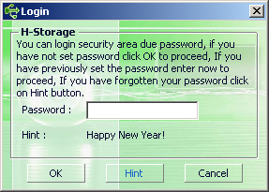

- You have three trials to input the password. After three trials, the following message will pop up. And you have to unplug and re-plug the device in order to do other actions.
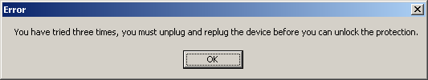
8-2 Click on the [OK] button.

- Logout the Security Data Zone:
There are three methods to logout security area:
9-1 Click the right mouse button and select H-Storage in the notification window, and select [logout] to exit the security area after the following window pops up
Warning: When you login or logout to/from the device, please make sure that neither applications nor file(s) in the device is running. Otherwise, it may cause data loss or damage.
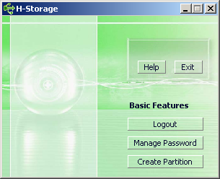

9-2 Click the right mouse button and select [Logout] or [Exit].
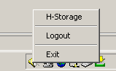

9-3 Double click the H-Storage icon in the notification window.
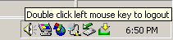
- Manage Password:
User can change password and key in the password hint by selecting the “Manage Password” function in the H-Storage main window. You can only select this item when the security area is activated.

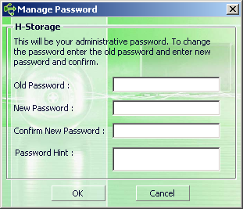

  - Make sure the “Write Protect” switch is at “OFF” location.
  - Key in your current password in the “Old Password” area.
  - Then, key in your new password and confirm in the “New Password” and “Confirm New Password” area. The maximum length of the password is 8 characters.
  - You can key in the hint of your new password in the “Password Hint” window. This hint will be displayed when you click the “Hint” button in the “Login” window.

PART III One-Touch Backup (OTB) -- the “Personal Backup”

    - How to install “Personal Backup”:
- Click “PersonalBK.exe” in the installation directory.
- The “Personal Backup” window shows.
- The “Personal Backup” icon is created on the system tray.
- The icon shows on the system tray when the program is running. Right click on the icon to select the desired command in the sub-menu.
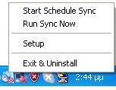
Note: The program can only be used with the authenticated device shipped within the package. Any other device will not work with this program.
    - Exit the program:
2-1. You have to run “Safely Remove Hardware” before you remove your storage device.
- Click on the icon on the system tray and select “Exit and Uninstall”.
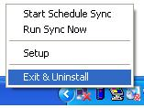
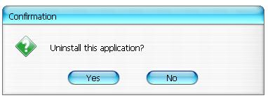
Click “Yes”.
- Run “Safely Remove Hardware” from the system tray.
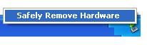
After you complete the “exit and uninstall” command, when you plug your storage device into the USB port on your computer, the icon won’t display on the system tray.
If you want to launch the program, please click “PersonalBK.exe” in the Installation directory.
2-2. You can remove the device directly after you shut down the computer.
Note: The data will be lost If you remove the device before running the “Safely Remove Hardware” command during the computer is under operation.

    - Personal Backup:
You can define synchronization configurations or synchronize the selected folder for data backup and create links for backup.
    - Personal Backup Settings:
      - Click on the icon on the system tray and select “Setup”.
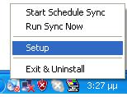
Choose <Setup> to prompt the <Personal Backup Settings> window. The <Add New>, <Copy>, <Edit>, <Delete>buttons are in the upper part of the window, and the <Save and Test>, <Save and Apply>, and<Close> buttons are in the lower part of the window.
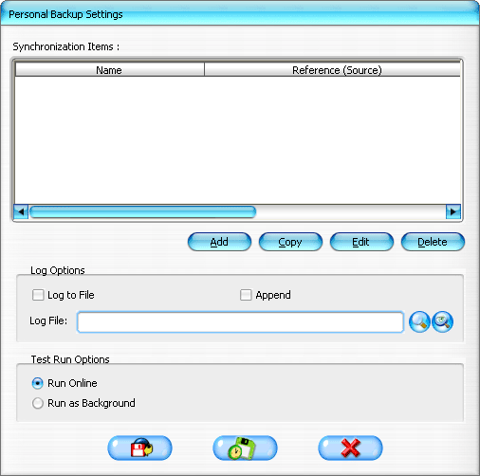
    - [Add] new sync items:
Click on<Add New> button to enter the<Synchronization Folder>window.
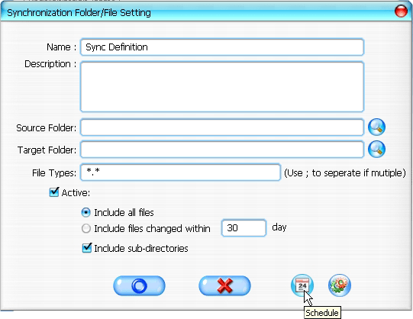
- Assign and enter the name and description of the synchronization item. Then enter the source folder and target folder to the box in the <Synchronization Folder> window. The default is set for all types of file format for backup, and can be changed to the specific file format(s) for backup assigned by the user.
- The synchronization will be run only if the items whose [Active] box is selected to run synchronization as scheduled.
- Setting schedule: Click on <Schedule> button to enter the<Schedule Setup>window. There are 4 types of schedule: Once, Daily, Weekly, and Monthly. There is also advance scheduling option for all types except the Once type.
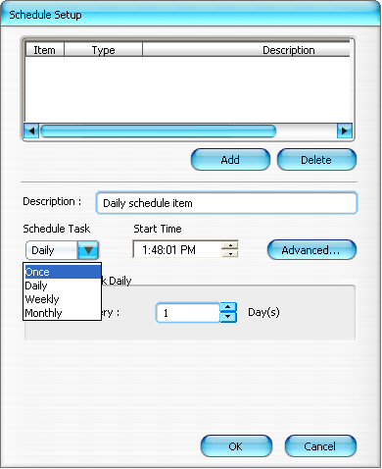
Multiple schedules can be applied at the same time within a synchronization setting. The schedule setting can be edited or deleted by selecting it and then clicking on the associated button.
- Advance Setting: click on <Advance Setting> button to enter Advanced Option setup window.
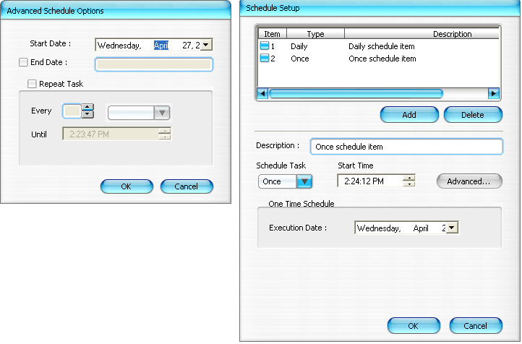
- Copy synchronization item:
Click on <Copy> button to copy the selected sync item.
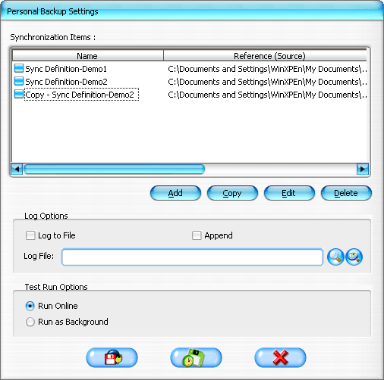
- Edit synchronization item:
Click on <Edit> button to edit the selected sync item.
- Delete synchronization item:
Click on <Delete> button to delete the selected sync item. A confirmation message will appear.
The item will be deleted after the user confirms the action.

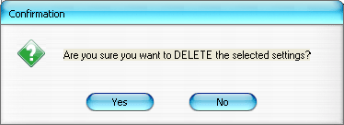
- Log Options
Record the state of data transmission. If you check the “Append” box, the program will delete files from the coldest one when the space is full.
- Test Run Options
It’s an option for [Save and Test]. If you select [Run Online], the “File Synchronization” window will display during the backup testing. If you select [Run as Background], the “File Synchronization” will not display during the backup testing (the program is running as background).
- Save and Apply -- After the synchronization configuration is done, the user must click on <Save and Apply> button to run the schedule with these settings, or click on <Save and Test> button to save these settings and test them out.
- Personal backup advanced settings

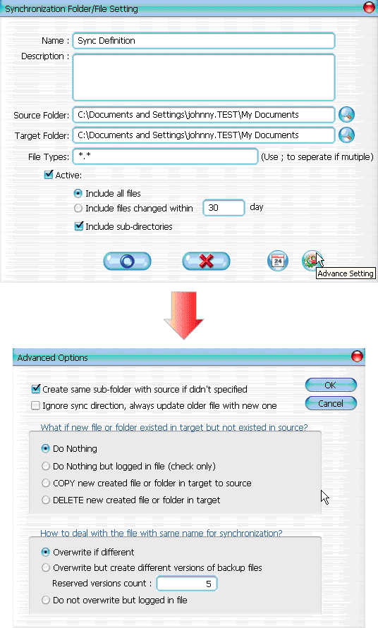
  - If the specified destination path does not contain the same subdirectories as the source directory, then auto generate directories.
- Checked: Generates a directory with the same name under the specified destination path, and then perform synchronization.
- Unchecked: The program will directly perform synchronization under the specified directory.
12-2 Ignore the sync direction; the newer file will always be updated over the older version.
- Checked: The program will automatically determine the newer version (the last modified) of files with the same name, dynamically decide the source and destination, and then overwrite the older file. If file logging is activated, when the sync process reverses the source and destination, the sync log will indicate as "###".
- Unchecked: The program will synchronize directly; it will not assist in the determination of new/old files.

12-3 How should files and/or folders that already exits in the destination path but not found in source path be handled?
- Ignore: This is the default option. The sync process will only synchronize files and folders from the source path.
- Ignore, only perform checkup and record: The sync process will synchronize files or folders from source path; the files and folders not in source will be recorded in the log file indicated by "###".
- Copy the files or folders from the destination path to source path: In addition to copying files and folders from the source to destination path, the sync process will also copy the files and folders from the destination to source path.
- Delete the files and folders in destination path: The sync process will delete files and folders that exist only in the destination path but not in the source path.
12-4 How should duplicated file names be handled during the sync process?
- File modified, and then overwritten: This is the default option. If the sync process finds that the file is modified, it will be overwritten.
- File modified, then before being overwritten, generates different versions of backup files: Backup the file before updating. The backup naming convention is "original_name_V#" (# is the version number). i.e.: the original file name is TestFile.txt, then, the backup file name is TestFile_V1.txt.
- File modified, will not be overwritten, but recorded in log file: When the sync process finds that the file is modified, it will not be overwritten and only be recorded in the log file.

- Start scheduled sync:

Right click on the program icon on the system tray and select “Start Schedule Sync” command. After all configurations are done, backup procedures will be undertaken according to the schedule.
  - The icon on the system tray becomes the one without the cross.
  - Right click on the program icon on the system tray, it shows[Personal Backup-Schedule sync running…].
  - Click on the icon and select “Start Schedule Sync” command to switch to “Stop Schedule Sync”.
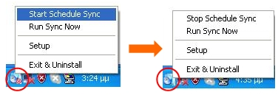
- Run Sync now
  - Click on the icon on the system tray and select “Run Sync Now”.

The window shows and lists all available options. Click “Run” to synchronize your data and display the log file.
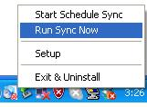
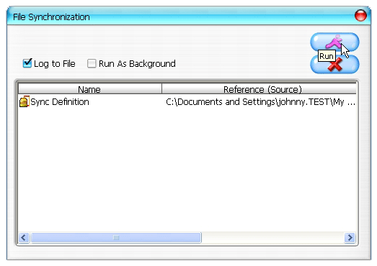

14-2 Press on the [Hot Key] button manually to run the synchronization backup.
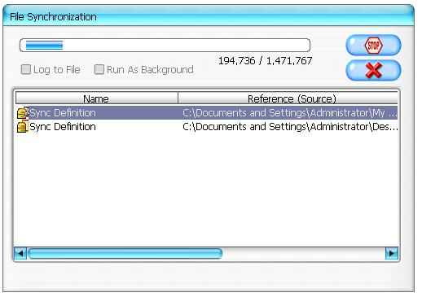
Appendix：
Product Features | USB HDD Enclosure with 1-Botton Backup & Security functions, and soft-touch button control.
Interface | USB2.0 Interface
HDD Type | 2.5 inches HDD
Max. HDD Capacity | 120GB
Power Supply | Directly from USB port, with Auxiliary DC power supply
Driver | WINDOWS98 Driver
System Requirements
Computers | IBM or Compatibles PC or Notebook
Computers | Apply Mac Family
OS Environment | WINDOWS98SE/2000/ME/2003/XP
OS Environment | MAC OS9.0 or above
OS Environment | LINUX9.0 KERNEL 2.4.20-8

Disclaimer
We made every effort to ensure that the information and procedures in this guide are accurate and complete; no liability can be accepted for any errors or omissions. Ours Technology Inc. (OTI) reserves the right to make any changes without further notice to any products herein.

Trademark Acknowledgments
- IBM is a registered trademark of international Business Machines Corporation.
- iBook and iMac are trademarks of Apple Computer, Inc.
- Macintosh, PowerBook, Power Macintosh are trademarks of Apple Computer, Inc.
- Microsoft, Windows, Windows 98, Windows ME, Windows 2000, Windows XP, and Windows 2003 Server are either registered trademarks of Microsoft Corporation in the United Stats and/or other countries.
Other names and products not mentioned above may be registered trademarks of their respective companies.

