

Pocket Drive II

USB2.0 External HDD

User’s Manual

Version 2.0
Table of Contents

- Getting Started
  - Safety Precautions
  - System Requirements
  - Package Content
  - Product Views
  - Product Feature Overview
- Operating Instructions
  - Basic Functions
    - Plug & Play Feature
    - To Read & Write
    - To Remove Device
  - Using SecureDrive EX Software
    - To Install SecureDrive EX
    - Setting Your Own Password
    - To Lock/Unlock Security Section
      - To Lock Security Section
      - To Unlock Security Section
    - To Safely Remove Pocket Drive II
    - Setup Options
    - To Uninstall SecureDrive EX
    - Other Functions
  - Using One Touch Backup (OTB)
    - To Install PCCloneEX
    - Regular File Backup Functions
      - To Backup File
      - To Restore File
      - To Delete Backup File
    - Quick Launch
      - To Backup File using Quick Launch
    - To Backup File using One Touch Backup
    - File Manager
    - Setup
    - Other functions
- Appendix
  - Product Specifications
  - Supporting OS
  - Disclaimer
  - Trademark Acknowledements

- Getting Started

Thank you for purchasing Pocket Drive II, a Leather HDD Enclosure. You have made an excellent choice and we hope you will enjoy all of its capabilities. The product offers a new concept of mobile data storage which features safety and user friendliness. Please read through the user manual carefully before using the product, and follow all of the procedures in the manual to fully enjoy all features of the product.

  - Safety Precautions

Please observe all safety precautions before using Pocket Drive II. Please follow all procedures outlined in this manual to correctly operate the device.

Warnings: This mark indicates actions that could lead to serious injury to personnel operating the device or damage to the device if ignored or handled incorrectly.

- Do not attempt to disassemble or alter any part of the device that is not described in this guide.
- Do not place the device in contact with water or any other liquids. The device is NOT designed to be liquid proof of any sort.
- In the event of liquid entry into interior of device, immediately disconnect the device from the computer. Continuing use of the device may result in fire or electrical shock. Please consult your product distributor or the closest support center.
- To avoid risk of electrical shock, do not connect or disconnect the device with wet hands.
- Do not place the device near a heat source or directly expose it to flame or heat.
- Never place the device in vicinity of equipments generating strong electromagnetic fields. Exposure to strong magnetic fields may cause malfunctions or data corruption and loss.

  - System Requirments

Below are minimum hardware and software requirements that must be satisfied to ensure the device function properly.
- Computer : IBM PC/AT Compatible Personal computers
- Supported OS:
IBM PC Compatible :
-Microsoft Windows 98SE / Me / 2000 / XP / Windows 2003 Server / Vista
Mac OS :
-Mac OS 9.x and 10.x or higher (FAT32 format only)
Linux :
-Linux 2.4 or higher (FAT32 format only)
- CPU: Pentium or above
- Memory: Minimum of 32MB of RAM
- Display card: Compatible with VESA standard
- User Authority: Administrator
- Optical drives: CD ROM or CD ROM compatible device
- Free hard disk space – no less than 16 MB (3MB for Win 98 driver and 30MB for Personal Backup application)

NOTE:
Windows 98 SE does not support default mass storage driver. Please follow the instructions below to install the driver.
- Turn on the computer
- Connect Pocket Drive II to the USB port of the computer using USB cable in the package.
- Place the driver CD enclosed in the package into the CD ROM drive of the computer.
- Windows 98 SE will automatically detect the newly connected Pocket Drive II and a dialog box “Add New Hardware” will pop up. Please follow the step-by-step instructions to properly install the driver.

  - Package Content

Name/Description | Quantity
HDD Enclosure Main Unit | 1
30cm USB Cable | 1
Stylish Carrying Case | 1
Driver and Software CD | 1
User Manual | 1

  - Product Views

Top View
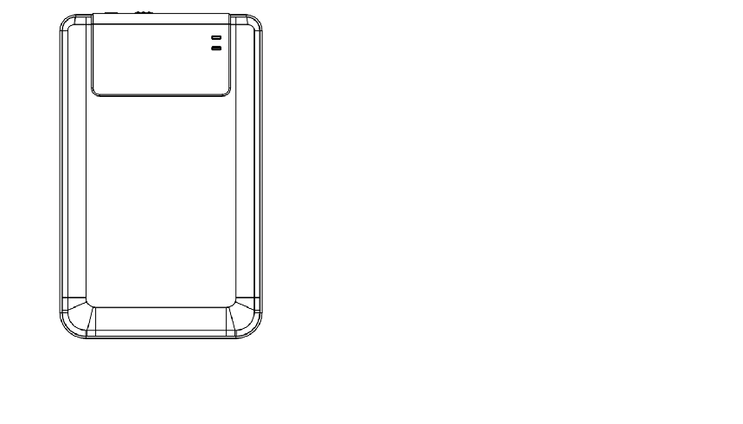
POWER LED

R/W LED
Front View
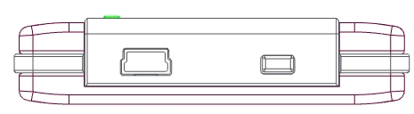

USB Port COPY

  - Product Feature Overview

- Classy Leather Coated Craftsmanship
Pocket Drive II brings luxury and simplicity into your daily digital lives.
- Maximum Data Security (SecureDrive EX)
With SecureDrive EX application software, you can protect your device with password log-in and partition your device into “Public” and “Security” sections.
- Public Section – Public Section does not support password protection. You can still perform every basic function described in the “Basic Functions” section.
- Security Section – Security is not accessible without security login. Only login software is available in the section when locked. Please note that AP Area cannot be read/written when locked.

- Operating Instrucitons
Warnings: The device is fully compatible for basic functions with computers specified at “System Requirements” session, however, both SecureDrive EX and PCClone EX DO NOT work on Mac OS and Linux OS.

  - Basic Functions

    - Plug & Play Feature

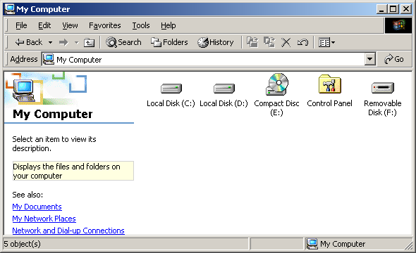

When you connect the device into the USB port of your computer, a “Removable Disk” icon will appear in the file manager window as shown above. On Macintosh machines, you can notice the disk icon in the “Desktop” once you plug in the device into the USB port.

In Linux OS, you can mount the device executing the following instructions.
■ Execute cd/etc/sysconfig/ (cat/etc/sysconfig/hwconf | more)
■ Check the device information in hwconf，write down the mount point.
■ Make a directory in/mnt (ex: mkdir/mnt/usbHD)
■ Then, execute mount/dev/sda1 /mnt/usbHD (if mount point was .dev/sda)

    - To Read & Write

You can retrieve or store files in the device as operating with a hard disk. The read/write operation of the device is the same as that of a hard disk.

    - To Remove Device

To minimize risks of data loss on Windows ME, 2000 and XP OS, please follow the removal procedures as follows:
- You can find the safe removal icon in your computer’s notification area.
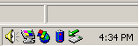
- Double click the “safe removal” icon; the “Unplug or Eject Hardware” window will pop up.
- You can select the device you want to remove. Then, click the [Stop] button. You can safely unplug the device from the USB port of your computer after.
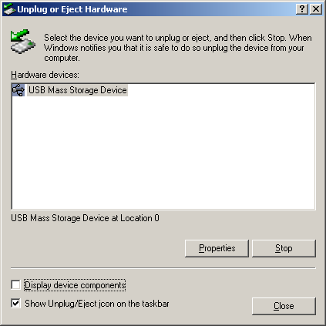

Warning: Before removing the USB device, make sure the LED is not flashing. There is traffic going on between the host computer and the USB device when the LED flashes quickly. Do NOT remove the USB device at this moment. Violation may cause data loss or even damages to the Pocket Drive II.

Warning: If you do not follow the safe removal procedures on Windows ME, Windows 2000 and Windows XP operating systems, data loss may occur due to “write cache” issue.

On Macintosh operating systems, you can drag the removable disk icon into the trash. This action will perform the “Eject” function.

On Linux operating system, please follow the “demount” procedure to demount the device.

  - Using SecureDrive Ex Software

With SecureDrive EX application software, you can protect your device with password and partition your device into “Public” and “Security” sections.

Warning: The Partitioning action will delete all the data in the device. The action is not reversible. Please back up all necessary data, and close all the active programs and windows on the computer before performing this action.

    - To Install SecureDrive EX
Warning: SecureDrive Ex is only able to handle one device at one time. The SecureDrive EX may not perform properly or even cause data loss if more than one device is being worked on.

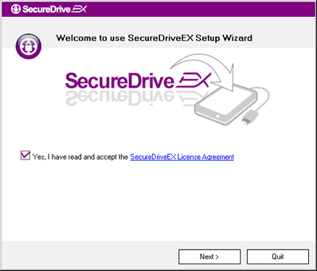 | - Connect Pocket Drive II to the host computer by the USB cable provided.  - Insert SecureDrive EX installation CD into CD ROM drive, SecureDrive EX window will automatically pop up. If nothing appears after a few moments, please double-click on Setup.exe under “My Computer” -> CD ROM drive.  - Please click on the SecureDrive EX License Agreement and read through the agreement for legal usage.  - Place a check in the box and then click "Next".


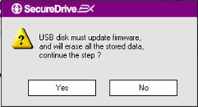 | - A dialog box will pop asking for firmware update confirmation. All data will be deleted permanently if executed. Click “Yes” to continue or click “No” to cancel firmware update.

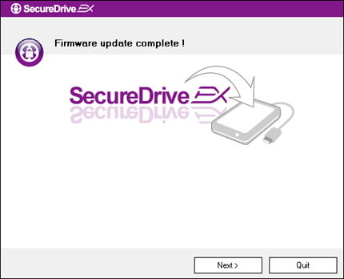 | - The firmware update process should not take more than 1 minute depending on the host computer capability.  - When the process is completed, please disconnect Pocket Drive II from the host computer.  - Please reconnect Pocket Drive II to the host computer.

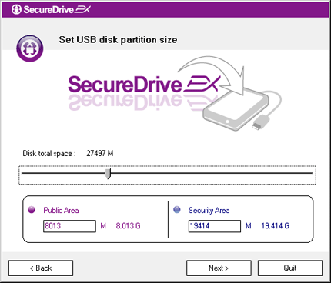 | - As shown in the diagram, Pocket Drive II storage will be divided into two sections, namely security section and public section.  - The capacities of two sections can be adjusted by clicking and dragging the pointer horizontally. You can also customize a specific size by typing into the appropriate box.  - Click “Next” to continue the partitioning process.

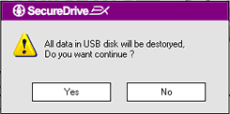 | - A dialog box will pop up asking for partitioning confirmation. All data will be deleted permanently if executed. Click “Yes” to continue partitioning process or “No” to cancel action.

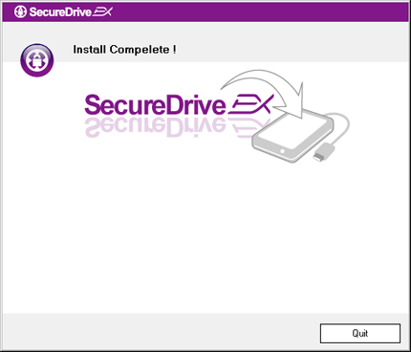 | - Partitioning process should not exceed 3 minutes depending on the computer capability. Please disconnect Pocket Drive II from host computer.

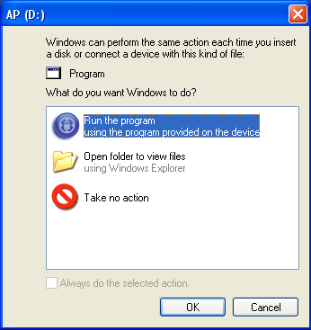 | - Reconnect Pocket Drive II.  - A window will pop up requesting for further instruction. Highlight “Run the program” option and click “OK” to continue installation process.

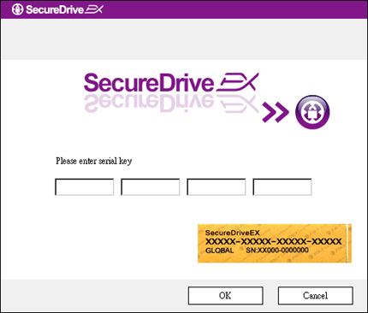 | - A SecureDrive EX window will pop up for authentication. Please refer to yellow sticker at the last page of user manual for serial key. Enter those numbers in the text fields provided. Click “OK” to Finish.

    - Setting Your Own Password

As mentioned above, SecureDrive EX offers 2 storage partitions, public section and security section for user’s convenience. It is recommended to setup a password for security section immediately to better protect confidential data. A password must be within 16 characters consisting of English alphabets and numerical characters. Please make sure to write down your password and store it at a safe place where you can always remember. Please connect Pocket Drive II to the host computer and turn on its power for further actions.

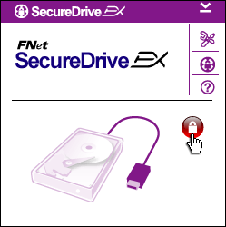 | - A window will pop up requesting for further instruction. Highlight “Run the program” option and click “OK” to continue.  - Click on the red "Lock" icon to unlock security section.  - A small window will pop up indicating unlocking sequence is in process.

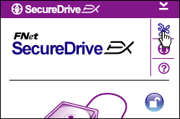 | - A previously red “Lock” icon is now a blue “Unlock” icon. It represents the security section is open for use.  - Click on the “setup" icon after unlocking will bring up the setup menu.

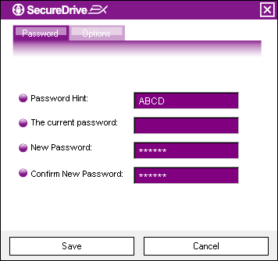 | - The Setup menu is set on password page by default. There are 4 text fields for user data input.  - Please input a password hint that serves as a reminder to help you better remember your own password.  - Please input the current password if a password change is desired. Please leave it blank for first time use.  - Please type in a new password and type again to confirm new password entry. Refer to the beginning of the section for password criteria.  - Click “Save” to save the password setting and “Cancel” to return to main menu.

    - To Lock/Unlock Security Section

Please make sure that Pocket Drive II is connected to the host computer and its power is ON.

      - To Lock Security Section
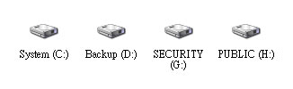 | - Click on “My Computer”.  - The security section is now accessible for data input/output.

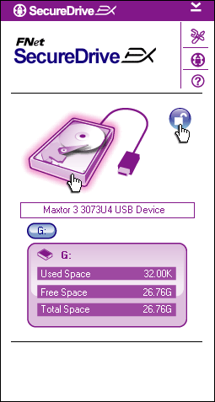 | - As mentioned in other section, a blue “Unlock” icon indicates an open security section.  - To lock up, click on blue “Unlock” icon or the HDD graphic to initiate locking sequence.  - A small window will pop up indicating locking sequence is in process.

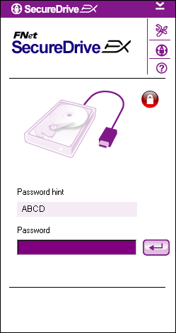 | - A red “Lock” icon indicates security section has been successfully locked up. The password input request will also be displayed.

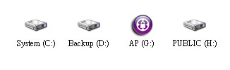 | - Click on “My Computer”.  - Security Section is now replaced by AP drive indicating it is locked up for data input/output.

- Click on “My Computer”.
- AP drive is displayed instead of security section indicating it is locked up for data input/output.

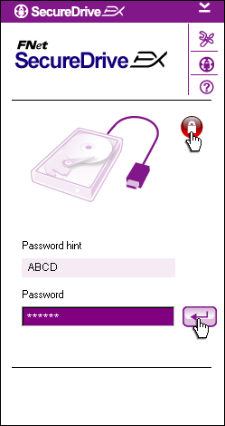 | - As mentioned in above session, a red “Lock” icon indicates the security section is locked up.  - To unlock, simply type in your password in the text field and either click on “return” icon or click on the red “Lock” icon to initiate unlocking sequence.  - A small window will pop up indicating unlocking sequence is in process.

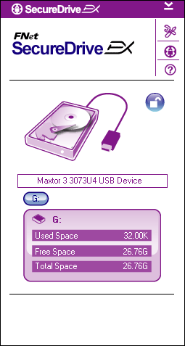 | - A blue “Unlock” icon indicates security section has been successfully unlocked. The information of Pocket Drive II will be displayed at the bottom of SecureDrive EX for user’s reference.

- Click on “My Computer”.
- AP drive is now replaced by Security Section indicating it is unlocked for data input/output.
Warning: When performing he lock and unlock actions with the device, please make sure there is no other applications or programs running or document not closed on the device. Violation may cause data loss or damage if so.

    - To Safely Remove Pocket Drive II

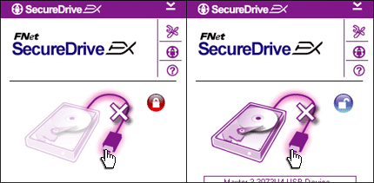 | - Regardless the state of the security area (lock/unlock), Pocket Drive II can be safely removed from the host computer.  - Click on the transfer cable to remove the Pocket Drive II.

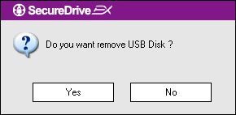 | - A dialog box will pop confirming the removal of Pocket Drive II.  - Click “Yes” to proceed removal action and “No” to cancel action.

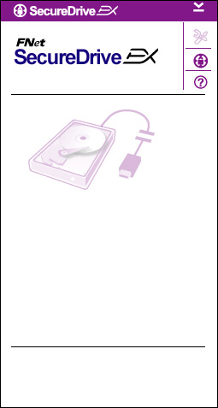 | - The Pocket Drive II has been disconnected. The transfer cable appears separated.  - Removing Pocket Drive II under the status of unlock will automatically lock up the security section.  - To access SecureDrive EX again after removal of Pocket Drive II, please disconnect Pocket Drive II and reconnect it to the host computer.

    - Setup

Please make sure that Pocket Drive II is connected to the host computer and its power is ON.

- Click on “Setup” icon.
- The “Setup” menu will pop up for further configurations.

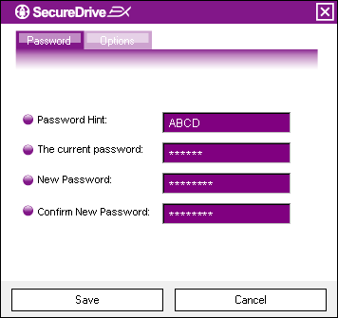 | - Please refer to the “Setting Your Own Password” session for configuring password options.  - To change your password, please type in the current password, new password, and confirm new password. Click on “Save” to save settings and “Cancel” to return.  - Click on “X” at the top right corner or “Cancel” to exit Setup menu.

    - To Uninstall SecureDrive EX

Please make sure that Pocket Drive II is connected to the host computer and its power is ON.
Warning: After uninstalling SecureDrive Ex, all data in Pocket Drive II will be deleted permanently. In addition, new partition has to be created from the windows disk management.

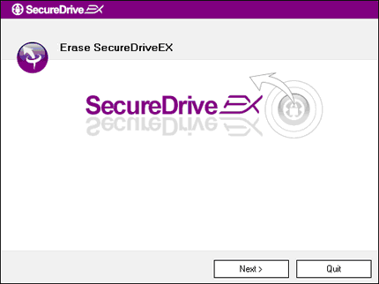 | - Insert SecureDrive EX installation CD into CD ROM drive of host computer.  - A SecureDrive EX setup window will pop up. Click on the “Remove Software” option.  - If no window pops up after a few moments, please click on the autorun.exe under “My Computer” -> CD ROM drive.  - Select your menu language and click on “Next” to proceed uninstalling process or “Quit” to cancel action.

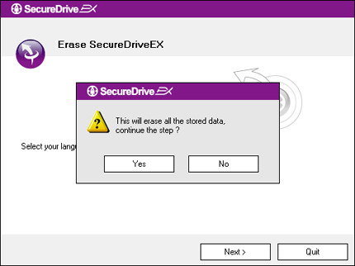 | - A dialog box will pop up requesting confirmation. Click “Yes” to continue or “No” to cancel action.

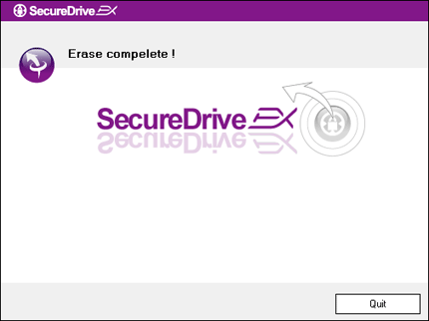 | - SecureDrive EX has been removed successfully. Click "Quit" to ext.  - Pocket Drive II is now restored to a regular external hard drive.

    - Other Functions

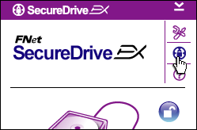 | Click on the "SecureDrive EX" icon for the detailed software specification.
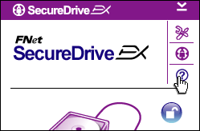 | Please click on “?” icon at the top right to display Help Center, a tutorial tool that helps user to better use SecureDrive EX.
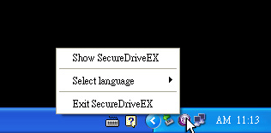 | Right-click on the SecureDrive EX icon at the desktop notification area to display shortcuts of partial functions.

  - Using One Touch Backup (OTB)
Warning: Pocket Drive II must be unlocked before executing any PCClone EX operations. Please make sure Pocket Drive II is unlocked during all PCClone EX operations. Violation may result in data loss or damage.

    - To Install PCCloneEX

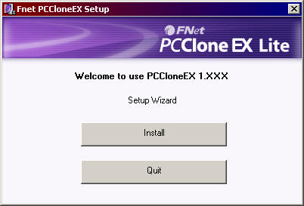 | - Please insert installation CD into CD ROM drive, and click on the One-Touch Backup Software option.  - If no window pops up after a few moments, please click on the autorun.exe under “My Computer” -> CD ROM drive.  - Click on “install” to initiate installation process and “Quit” to cancel.

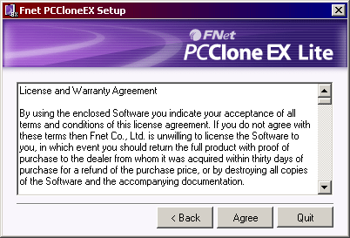 | - Please read through the license agreement in detail.  - If user accepts the agreement, please click “Agree” to continue or “Quit” to cancel installation.

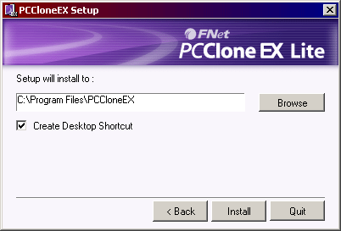 | - Please specify the installation path of PCClonEX. You can also click on “Browse” to examine the tree diagram.  - A check mark will be placed at “Create Desktop Shortcut” option by default. Remove the check mark if necessary.  - Click on “Install” to proceed or “Quit” to cancel action.

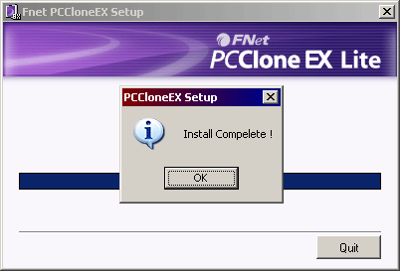 | - The installation process should only take a few moments. A dialog box will pop up when it is completed, please click “OK” to exit installation.

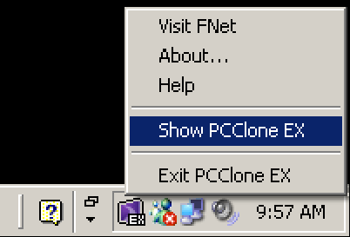 | - PCCloneEX icon will be displayed at the desktop notification area after setup. Users can double click or right click the icon to execute PCClone EX.
Warning: The program can only be used with the device shipped within the package. Any other devices will not work with this program.

    - Regular File Backup Functions

Please make sure that Pocket Drive II is connected to the host computer.

      - To Backup File

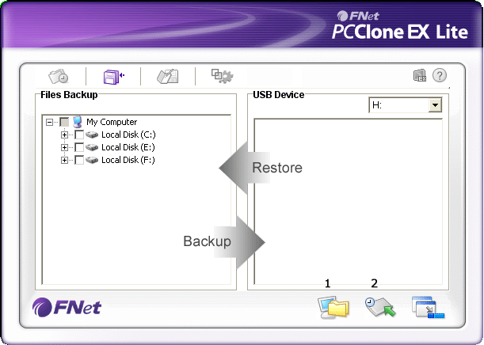 | - Click on “PCCloneEX” desktop shortcut to execute program..  - Click on “File Backup” tab to specify Backup/Restore paths.

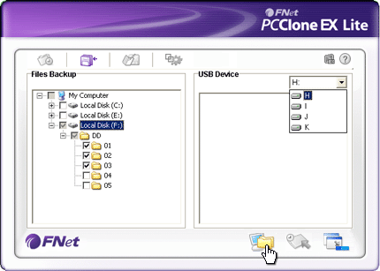 | - Under “Files Backup” column, place check mark(s) at the file(s)/folder(s) that are to be backed up.  - Under “USB Device” column, click on the drop down box to select designated back up storage device.

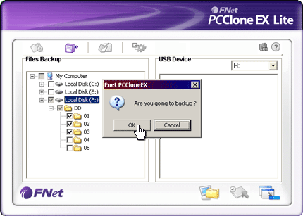 | - Click on “Backup” to start backup process. A dialog box will pop up confirming action. Please click on “OK” to continue and press “Cancel” to cancel action.  - Another dialog box will pop up when the process is completed. Please click “OK” to exit.

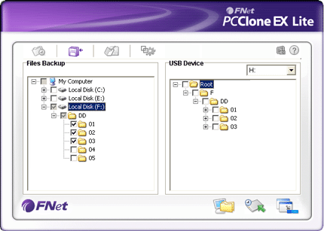 | - The selected file(s)/folder(s) have been backed up from the host computer to Pocket Drive II successfully.
Warning: There is a hidden root directory F: FNet in Pocket Drive II. All the backup file(s)/folder(s) will be kept in the directory Please do not remove the directory.

      - To Restore File

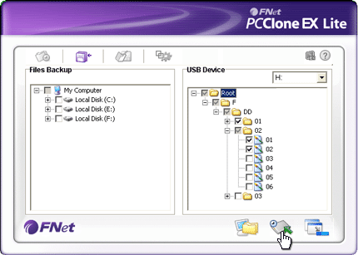 | - Click on “PCCloneEX” desktop shortcut to execute program.  - Click on “File Backup” tab to specify Backup/Restore paths.  - Under USB Device column, select folder(s)/file(s) that are ready to be restored.

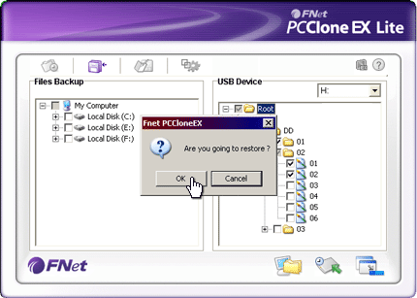 | - Click on “Restore” to start restoring process. A dialog box will pop up confirming action. Please click on “OK” to continue and press “Cancel” to cancel action.  - Another dialog box will pop up when the process is completed. Please click “OK” to exit.

      - To Delete Backup File

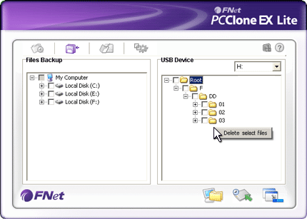 | - Click on “PCCloneEX” desktop shortcut to execute program.  - Click on “File Backup” tab to display backup information.  - Under USB Device, right click on the folder(s)/file(s) that are no longer needed and click “Delete select files” to remove them.

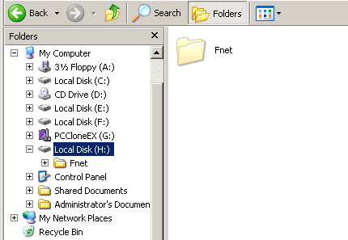 | - Backup folder(s)/file(s) can also be deleted at Windows file manager. Simply remove the “Fnet” root directory.

    - Quick Launch

Quick launch is designed as a shortcut for users to backup folder(s)/file(s) with one click or user defined hotkey. The system will back up selected entities upon executing quick launch function. For first time use, please refer to “To File Backup” session for selecting preferred files to back up and “Setup session” for hotkey setup.

Please make sure that Pocket Drive II is connected to the host computer.

      - To Backup File using Quick Launch

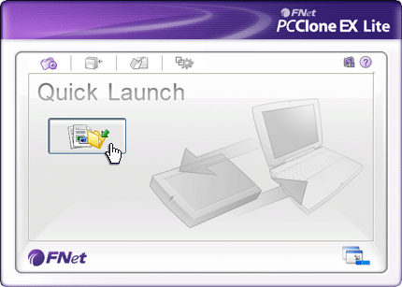 | - Click on “PCCloneEX” desktop shortcut to execute program.  - Click on “Quick Launch” tab.  - Click on “File Backup” or press the hotkey combinations to backup selected folder(s)/file(s).

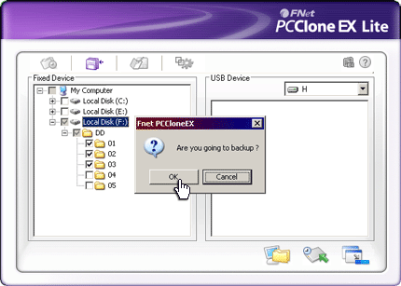 | - A dialog box will pop up requesting backup confirmation. Click “OK” to proceed and “Cancel” to cancel action.  - Another dialog box will pop up confirming back up action completion. Click “OK” to exit.
    - To Backup File using One Touch Backup
This function allows user to backup selected folder(s)/file(s) by only pressing one button on Pocket Drive II. Please be advised that this function is not supported by Windows 98 or Windows ME editions.

Please make sure that Pocket Drive II is connected to the host computer.
Warning: PCClone EX icon must be present at the desktop notification area before the “COPY” button on Pocket Drive II is pressed.

- Click on “PCCloneEX” desktop shortcut to execute program.
- Simply press the “COPY” button on the external casing

COPY

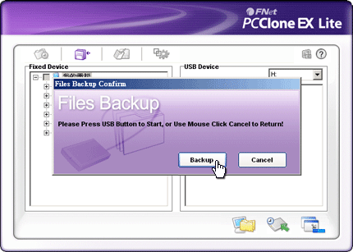 | - A dialog box will pop out confirming the File backup action. Click on “Start” or press the “COPY” button on Pocket Drive II again to continue. Click “Cancel” to cancel action.

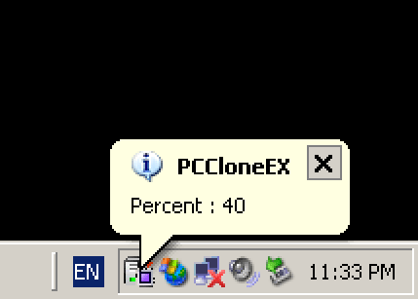 | - When the backup is in progress, PCClone EX icon will be flashing at the desktop notification area. A balloon box will pop up every time when the overall progress gains 10%.  - After the backup is completed, another balloon box from PCClone EX icon will pop up indicating backup completion.

    - File Manager

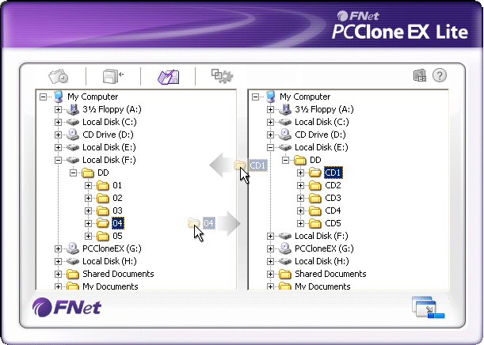 | PCClone EX File Manager functions similar to Windows Explorer. PC Users is free to drag folder(s)/file(s) back and forth between the host computer hard drive and Pocket Drive II. It is a feature designed for users to manage their folder(s)/file(s) without having to use “Windows Explorer” or “My Computer”.

    - Setup

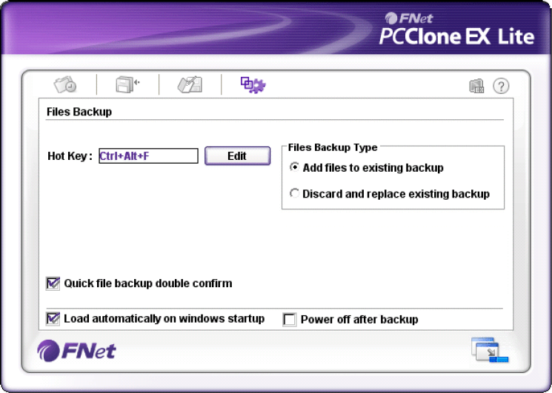

Hot Key | When “edit” button is clicked, a dialog box will pop up requesting user to input new hotkey combinations. Hold down any two of the following keys (Shift, Ctrl, and Alt) and another key to create new Hot Key. Click “Yes” to continue, “Cancel” to cancel.
File Backup Type | There are two types of file backup. First function, “Add files to existing backup”, only backs up additional folder(s)/file(s) to Pocket Drive II; while the other one, “Discard and replace existing backup”, duplicates all folder(s)/file(s) from the host computer to Pocket Drive II.
Quick file backup Confirmation | This option is check marked by default. When backup folder(s)/file(s) using hotkey, a dialog box will pop up requesting confirmation. Uncheck if necessary.
Start program on Window Startup | This option will allow PCCloneEX to load automatically when window starts. Uncheck if necessary.
Turn off computer after backup | This option will turn off host computer when backup is completed. Uncheck if necessary.

    - Other Functions

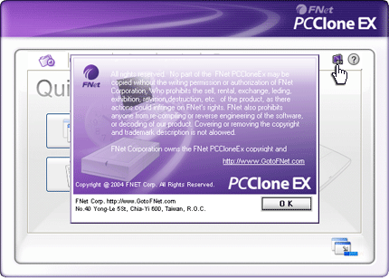 | Please click on “About” icon at the top right screen to review further specs of the program.

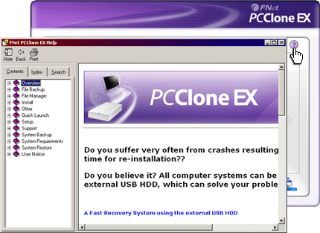 | Please click on “Help” icon at the top right to display Help Center, a tutorial tool that helps user to better use PCClone EX.

- Appendix

  - Product Specifications

Product Features | Pocket Drive II USB HDD Enclosure with 1-Botton Backup & Security functions, and soft-touch button control.
Interface | USB2.0 Interface
HDD Type | 1.8 inches ZIF type HDD
Max. HDD Capacity | Up to 80 GB
Power Supply | Directly from USB port
Driver | WINDOWS98 Driver

  - Supporting OS

IBM PC Compatible :
-Microsoft Windows 98SE / Me / 2000 / XP / Windows 2003 Server / Vista
Mac OS :
-Mac OS 9.x and 10.x or higher (FAT32 format only)
Linux :
-Linux 2.4 or higher (FAT32 format only)

  - Technical Support and Warranty Information

Please refer to www.prestigio.com for technical support and warranty information.

  - Disclaimer
We Made every effort to ensure that the information and procedures in this user manual are accurate and complete. No liability can and will be accepted for any erros or omissions. reserves the right to make any changes without further notice to any products herein.

  - Trademark Acknowledements

- IBM is a registered trademark of International Business Machines Corporation.
- iBook and iMac are tradmarks of Apple Coputer, Inc.
- Macintosh,k PowerBook, Power Macintosh are trademarks of Apple Computer, Inc.
- Microsoft, Windows, Windows 98, Windows ME, Windows 2000, Windows XP, Windows Vista, and Windows 2003 Server are either registered trademarks of Microsoft Corporation in the United States and/or other countires.

Other names and products not mentioned above may be registered trademarks of their respective companies.

